**PROJECT GLADIATOR**

**Retail Case Study**

**Team 8**

|  |
| --- |
| **Team Member** |
| Hansika Khadapkar |
| Nilesh Kumar |
| Rahul Noronha |

**Problem Definition:**

The Pricing Summary Report Query provides a summary pricing report for all line items shipped as of a given date. The date is within 60-120 days of the greatest ship date contained in the database.The query lists totals for extended price, discounted extended price, discounted extended price plus tax, average quantity, average extended price, and average discount. These aggregates are grouped by RETURNFLAG and LINESTATUS, and listed in ascending order of RETURNFLAG and LINESTATUS. A count of the number of line items in each group is included.

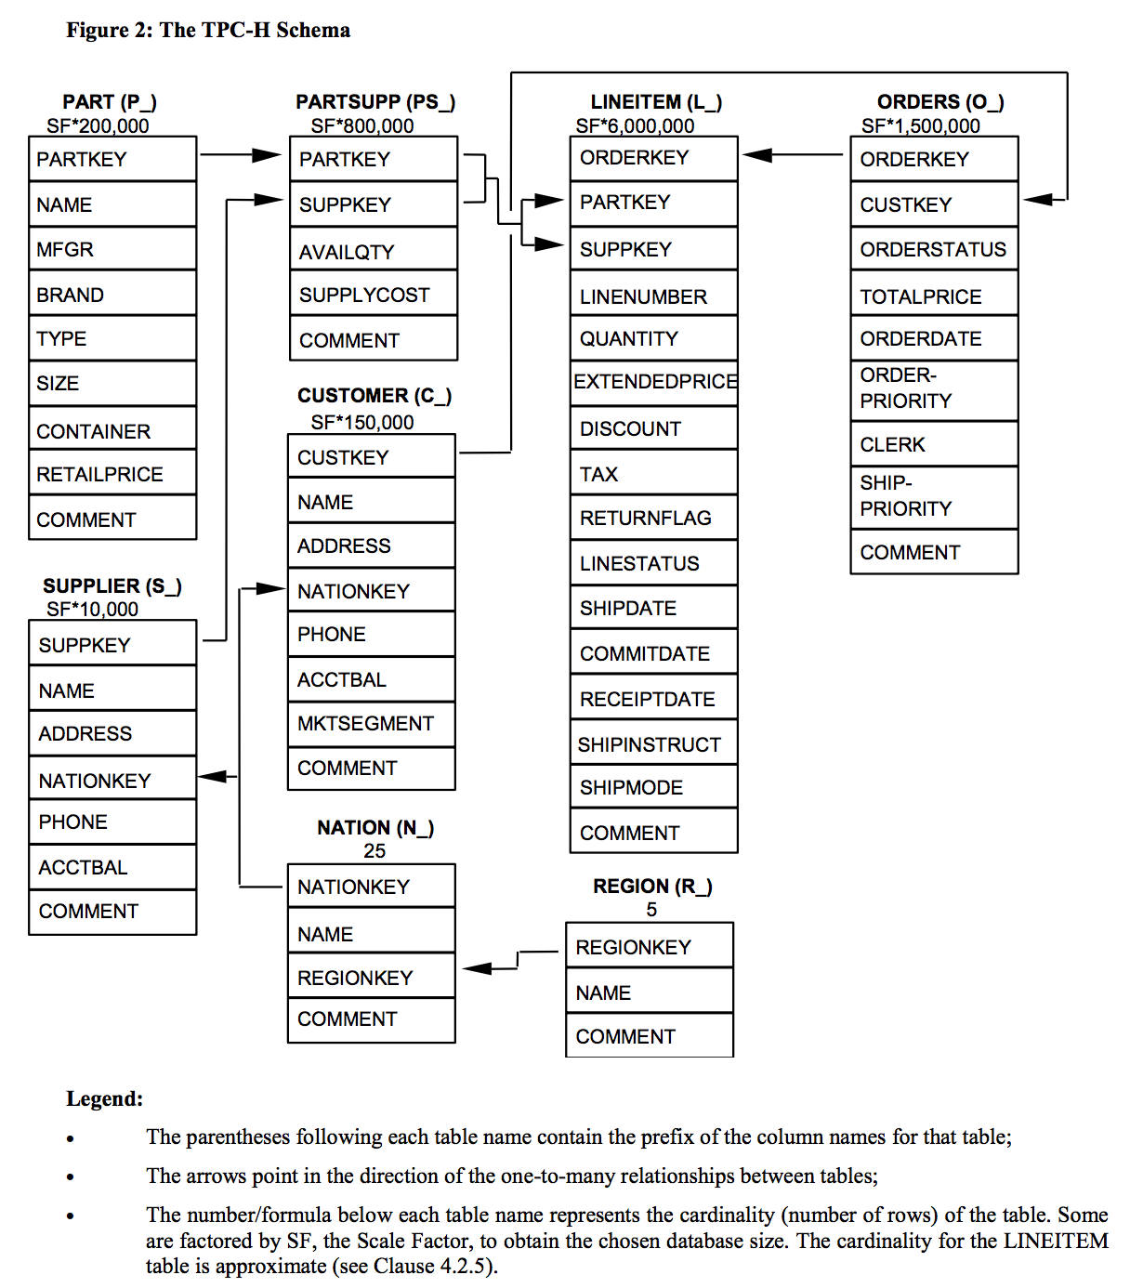

Figure 1. TPC-H Schema

**Tasks:**

1. Create database retail_db and schema retail_schema

2. Create 8 retail tables based on the diagram and apply cluster keys on the most

used columns for querying.

3. Add the table definition with constraints , unicode and data retention.

4. Create internal stage and load customer ,lineitem ,nation and orders

5. Load part,partsupp,region and supplier csv files into AWS s3 bucket

snow_extstage

6. Load the data from external stage

7. Perform bad records filtering on loading ,file format and compression

8. Create snowpipes to continuously load orders data from external stage from s3

bucket to the order staging table ,maintain the change data capture and merge

the data to the consumption table

9. Share your table to new non-snowflake user

10. create clone of the table with time travel before one day and write query to get

history data using particular timestamp

11. Create stored procedure to insert the data into table after typecasting date

format

12. Create a visualization for sales performance analysis using powerBI and prepare

reports /dashboard for business queries

**Datasets:**

<https://drive.google.com/drive/folders/1A3YDOT5ONTsyh6tXPOPEe7pQoGM5N3kj?usp=sharing>

We download the dataset in CSV format. There are 8 files, one for each table shown in the TPC-H Schema given in Figure 1.

|  |  |
| --- | --- |
| Table Name | Number of Rows |
| Region | 5 |
| Nation | 25 |
| Orders | 15,000 |
| Customer | 1,500 |
| Part | 2,000 |
| Supplier | 100 |
| PartSupp | 8,000 |
| LineItem | 60,175 |

**TASK 1**: Create database retail_db and schema retail_schema.

1. **The database is created as follows**

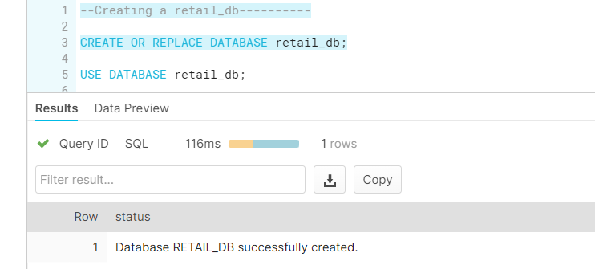

2. **The schema is created as follows**

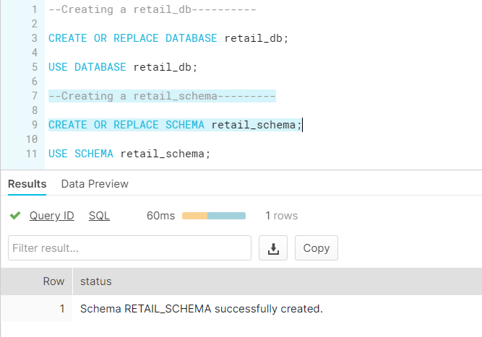

**TASK 2:** Create 8 retail tables based on the diagram and apply cluster keys on the most

used columns for querying.

**&**

**TASK 3:** Add the table definition with constraints , unicode and data retention.

**1. Region Table**: The Region table is created as follows

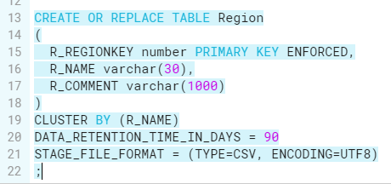

Here we set R_REGIONKEY as the primary key using- PRIMARY KEY

ENFORCED is used to ENFORCE the primary key constraint

CLUSTER BY (col1, col2, …coln)- Helps us choose cluster keys for our table. We thought the most appropriate CLUSTER KEY for the Region table would be the R_NAME since we can identify the region easily using the region name (R_NAME).

We set the data retention time in days as 90, which is the maximum allowed number of days to retain the data before it goes into fail-safe mode in the Enterprise Edition of Snowflake, which we are using.

We set the STAGE_FILE_FORMAT to TYPE=CSV since we are loading the data from the CSV file and we set the ENCODING to UTF8.

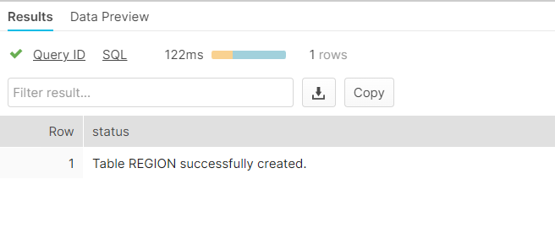

**2. Nation Table**: The Nation table is created as follows

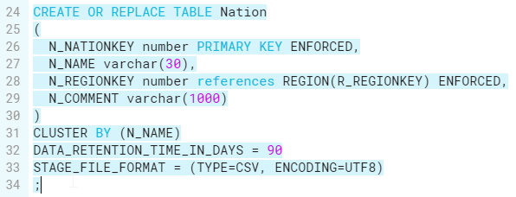

Here we set N_NATIONKEY as the primary key using- PRIMARY KEY

ENFORCED is used to ENFORCE the primary key constraint

We chose the FOREIGN key as N_REGIONKEY which references REGION(R_REGIONKEY) and ENFORCED is used to ENFORCE the constraint

CLUSTER BY (col1, col2, …coln)- Helps us choose cluster keys for our table. We thought the most appropriate CLUSTER KEY for the Nation table would be the N_NAME since we can identify the Nation easily using the Nation name (N_NAME).

We set the data retention time in days as 90, which is the maximum allowed number of days to retain the data before it goes into fail-safe mode in the Enterprise Edition of Snowflake, which we are using.

We set the STAGE_FILE_FORMAT to TYPE=CSV since we are loading the data from the CSV file and we set the ENCODING to UTF8.

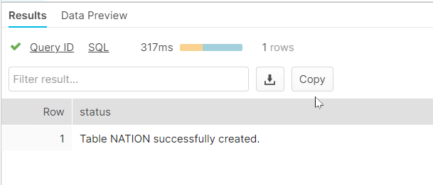

**3. Supplier Table**: The Supplier table is created as follows

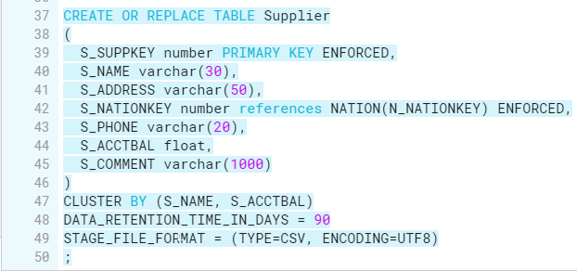

Here we set S_SUPPKEY as the primary key using- PRIMARY KEY

ENFORCED is used to ENFORCE the primary key constraint

We chose the FOREIGN key as S_NATIONKEY which references NATION(N_NATIONKEY) and ENFORCED is used to ENFORCE the constraint

CLUSTER BY (col1, col2, …coln)- Helps us choose cluster keys for our table. We thought the most appropriate CLUSTER KEY for the Supplier table would be the S_NAME and the S_ACCTBAL since we can identify the Supplier easily using the Supplier name (S_NAME) and the S_ACCTBAL seems like it will be queried a lot since it is a quantitative measure of the Supplier which reveals their performance.

We set the data retention time in days as 90, which is the maximum allowed number of days to retain the data before it goes into fail-safe mode in the Enterprise Edition of Snowflake, which we are using.

We set the STAGE_FILE_FORMAT to TYPE=CSV since we are loading the data from the CSV file and we set the ENCODING to UTF8.

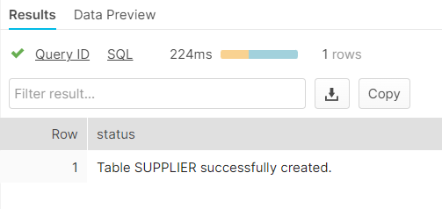

**4. Part Table**: The Part table is created as follows

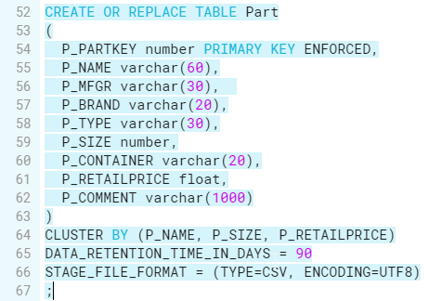

Here we set P_PARTKEY as the primary key using- PRIMARY KEY

ENFORCED is used to ENFORCE the primary key constraint

CLUSTER BY (col1, col2, …coln)- Helps us choose cluster keys for our table. We thought the most appropriate CLUSTER KEY for the Part table would be the P_NAME, P_SIZE, and P_RETAILPRICE since we can identify the Part easily using the Part name (P_NAME) and the fields P_SIZE, and P_RETAILPRICE seem like they will be queried a lot since they are quantitative measures of the Part which reveals about the Part.

We set the data retention time in days as 90, which is the maximum allowed number of days to retain the data before it goes into fail-safe mode in the Enterprise Edition of Snowflake, which we are using.

We set the STAGE_FILE_FORMAT to TYPE=CSV since we are loading the data from the CSV file and we set the ENCODING to UTF8.

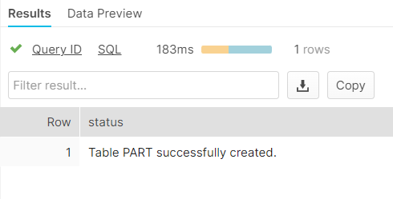

**5. PartSupp Table**: The Part-Supplier table is created as follows

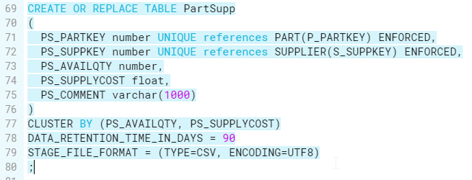

We chose the FOREIGN keys as PS_PARTKEY which references PART(P_PARTKEY) and PS_SUPPKEY which references SUPPLIER(S_SUPPKEY) and ENFORCED is used to ENFORCE the constraint. UNIQUE is added because these are referenced by LINEITEM table which is defined at the end.

CLUSTER BY (col1, col2, …coln)- Helps us choose cluster keys for our table. We thought the most appropriate CLUSTER KEY for the Part table would be the PS_AVAILQTY, and PS_SUPPLYCOST since they seem like they will be queried a lot since they are quantitative measures of the Part-Supplier which reveals about the Part-Supplier.

We set the data retention time in days as 90, which is the maximum allowed number of days to retain the data before it goes into fail-safe mode in the Enterprise Edition of Snowflake, which we are using.

We set the STAGE_FILE_FORMAT to TYPE=CSV since we are loading the data from the CSV file and we set the ENCODING to UTF8.

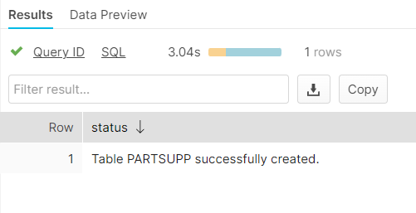

**6. Customer Table**: The Customer table is created as follows

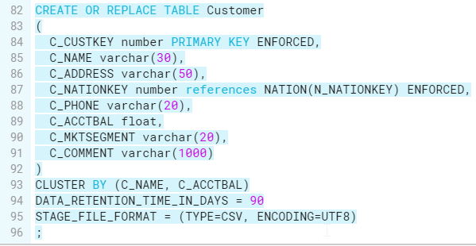

Here we set C_CUSTKEY as the primary key using- PRIMARY KEY

ENFORCED is used to ENFORCE the primary key constraint

We chose the FOREIGN key as C_NATIONKEY which references NATION(N_NATIONKEY) and ENFORCED is used to ENFORCE the constraint

CLUSTER BY (col1, col2, …coln)- Helps us choose cluster keys for our table. We thought the most appropriate CLUSTER KEY for the Customer table would be the C_NAME and the C_ACCTBAL since we can identify the Customer easily using the Customer name (C_NAME) and the C_ACCTBAL seems like it will be queried a lot since it is a quantitative measure of the Customer which reveals their performance.

We set the data retention time in days as 90, which is the maximum allowed number of days to retain the data before it goes into fail-safe mode in the Enterprise Edition of Snowflake, which we are using.

We set the STAGE_FILE_FORMAT to TYPE=CSV since we are loading the data from the CSV file and we set the ENCODING to UTF8.

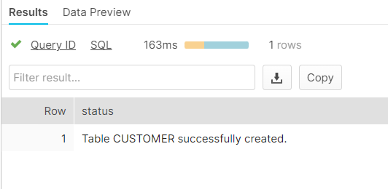

**7. Orders Table**: The Orders table is created as follows

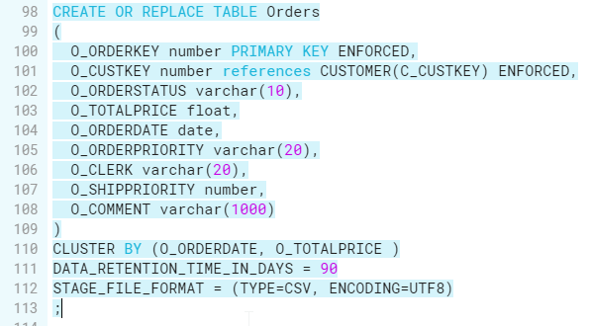

Here we set O_ORDERKEY as the primary key using- PRIMARY KEY

ENFORCED is used to ENFORCE the primary key constraint

We chose the FOREIGN key as O_CUSTKEY which references CUSTOMER(C_CUSTKEY) and ENFORCED is used to ENFORCE the constraint

CLUSTER BY (col1, col2, …coln)- Helps us choose cluster keys for our table. We thought the most appropriate CLUSTER KEY for the Orders table would be the O_ORDERDATE and the O_TOTALPRICE since they seem like they will be queried a lot being a creation date and quantitative measure respectively of the Customer.

We set the data retention time in days as 90, which is the maximum allowed number of days to retain the data before it goes into fail-safe mode in the Enterprise Edition of Snowflake, which we are using.

We set the STAGE_FILE_FORMAT to TYPE=CSV since we are loading the data from the CSV file and we set the ENCODING to UTF8.

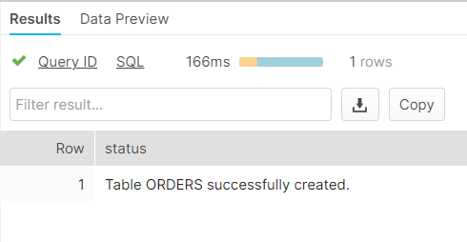

**8. LineItem Table**: The LineItem table is created as follows

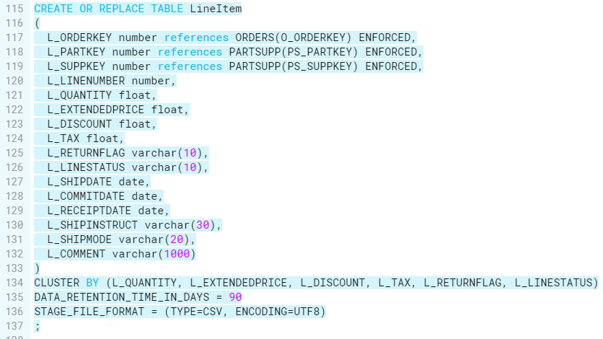

We chose the FOREIGN key as L_ORDERKEY which references ORDERS(O_ORDERKEY), L_PARTKEY which references PART(PS_PARTKEY), and L_SUPPKEY which references PARTSUPP(PS_SUPPKEY) and ENFORCED is used to ENFORCE the constraint

CLUSTER BY (col1, col2, …coln)- Helps us choose cluster keys for our table. We thought the most appropriate CLUSTER KEY for the LineItem table would be L_QUANTITY, L_EXTENDEDPRICE, L_DISCOUNT, L_TAX, L_RETURNFLAG, L_LINESTATUS since they seem like they will be queried a lot being quantitative measures of the LineItem table.

We set the data retention time in days as 90, which is the maximum allowed number of days to retain the data before it goes into fail-safe mode in the Enterprise Edition of Snowflake, which we are using.

We set the STAGE_FILE_FORMAT to TYPE=CSV since we are loading the data from the CSV file and we set the ENCODING to UTF8.

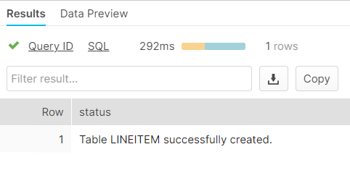

**TASK 4: Create Internal stage and load customer, lineitem, nation and orders**

1. **CREATING FILE FORMAT**

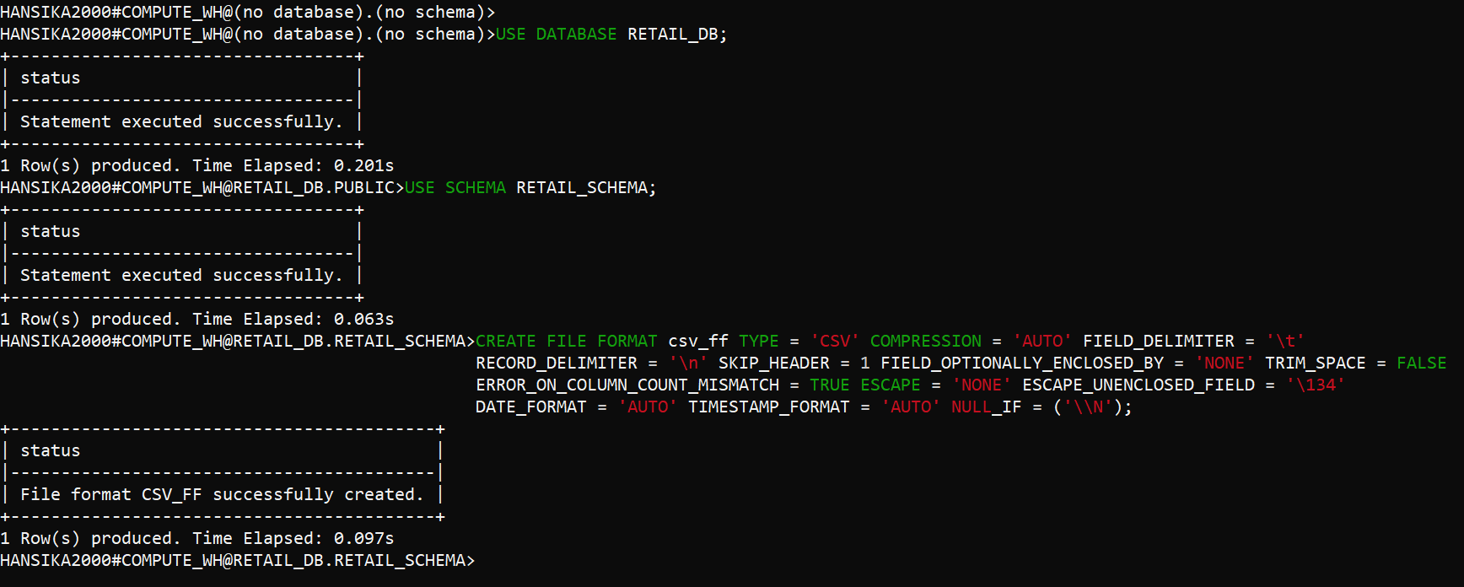

We have created a file format named **csv_ff** that describes a set of staged data to access or load into Snowflake tables.

Parameters:

**TYPE=’CSV’ :** TYPE Specifies the format of the input files (for data loading) or output files (for data unloading). We have set this parameter to CSV as the input files are in CSV format.

**COMPRESSION=‘AUTO’ :** When loading data, specifies the current compression algorithm for the data file and when unloading data, compresses the data file using the specified compression algorithm. We have set this parameter to AUTO so that the compression algorithm is detected automatically. When unloading data, files are automatically compressed using the default, which is gzip.

**FIELD_DELIMITER=’\t’ :** This parameter specifies one or more single byte or multibyte characters that separates fields in an input file or unloaded file. We have set this parameter to ‘\t’ since we observed the fields to be separated by ‘\t’.

**RECORD_DELIMITER=’\n’ :** This parameter specifies one or more single byte or multibyte characters that separate records in an input file or unloaded file. We have set this parameter to ‘\n’.

**SKIP_HEADER=1 :** Specifies number of lines at the start of the file to skip. We have set this parameter to 1 as we are skipping the header line.

**FIELD_OPTIONALLY_ENCLOSED_BY='NONE’ :** Character used to enclose strings. When a field contains this character, it escapes it using the same character.

**TRIM_SPACE= FALSE :** Boolean that specifies whether to remove white space from fields. When set to FALSE, snowflake reads the leading space if any, as the beginning of the field.

**ERROR_ON_COLUMN_COUNT_MISMATCH=TRUE :** Boolean that specifies whether to generate a parsing error if the number of delimited columns (i.e. fields) in an input file does not match the number of columns in the corresponding table. When set to TRUE, an error is generated on column count mismatch.

**ESCAPE=NONE :** A single byte character string used as the escape character for enclosed or unenclosed field values. You can use the ESCAPE character to interpret instances of the FIELD_DELIMITER or RECORD_DELIMITER characters in the data as literals.

**ESCAPE_UNENCLOSED_FIELD=NONE :** Specifies the escape character for unenclosed fields only.

**DATE_FORMAT=AUTO :** Defines the format of date string values in the data files. AUTO specifies that Snowflake attempts to automatically detect the format of dates stored in the system during the session.

**TIME_FORMAT=AUTO :** Defines the format of timestamp string values in the data files. AUTO specifies that Snowflake attempts to automatically detect the format of timestamps stored in the system during the session.

**NULL_IF = (‘\\N’) :** String used to convert to and from SQL NULL. Snowflake replaces these strings in the data load source with SQL NULL.

1. **LOADING nation table using named internal stage**

In the below step, we have created a named internal stage called my_internal_stage. By specifying a named file format object for the stage, it is not necessary to later specify the same file format options in the COPY command used to load data from the stage.

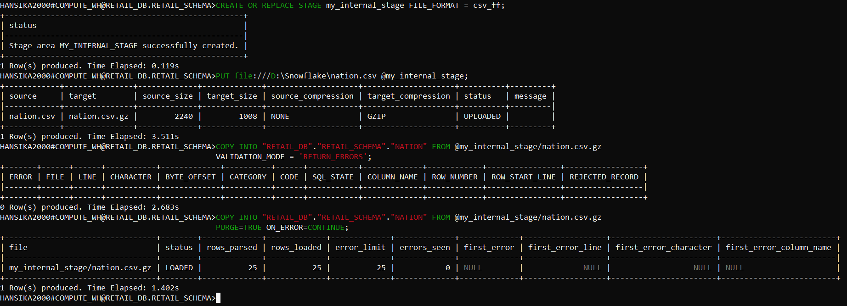

* PUT command is used to upload a file named nation.csv on local machine to a named internal stage called my_internal_stage
* VALIDATION_MODE parameter in a COPY statement is used to validate the staged data rather than load it into the target table.
* [COPY INTO <table>](https://docs.snowflake.com/en/sql-reference/sql/copy-into-table.html) loads data from file nation.csv.gz in my_internal_stage into nation table
* PURGE=TRUE is used to purge all files that are successfully loaded into the table
* ON_ERROR = CONTINUE continues to load the file with valid data if errors are found.

1. **LOADING lineitem table and customer table using table stage**

In the below step, we have loaded the tables lineitem and customer using the table stage.

* Each table has a Snowflake stage allocated to it by default for storing files
* Table stages have the same name as the table
* Unlike named stages, table stages cannot be altered or dropped
* Table stages do not support setting file format options. Instead, you must specify file format and copy options as part of the [COPY INTO <table>](https://docs.snowflake.com/en/sql-reference/sql/copy-into-table.html) command

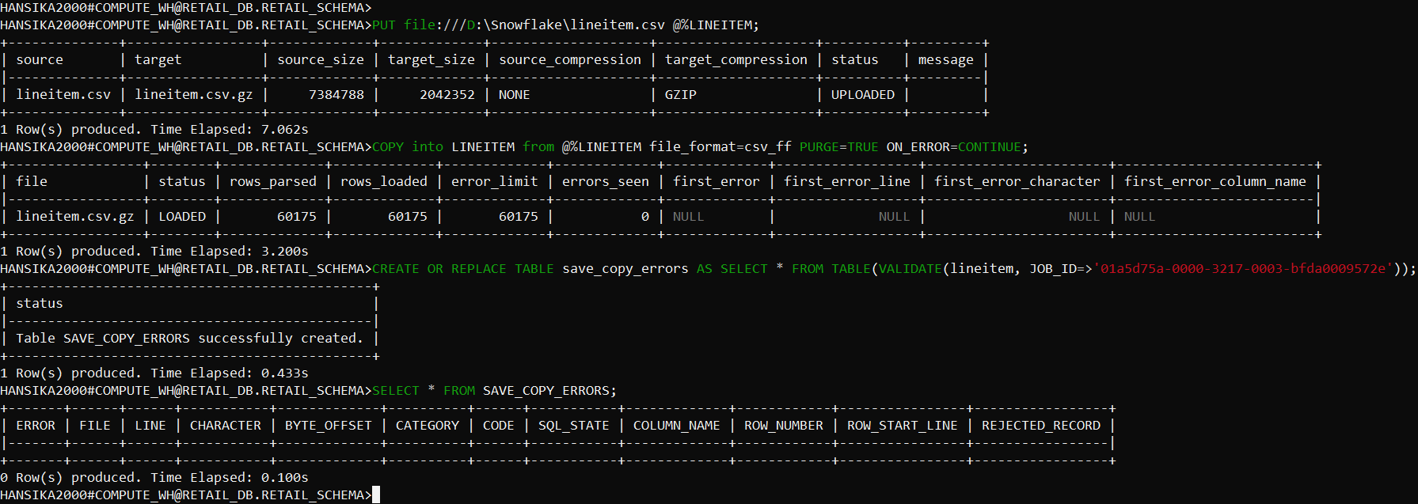

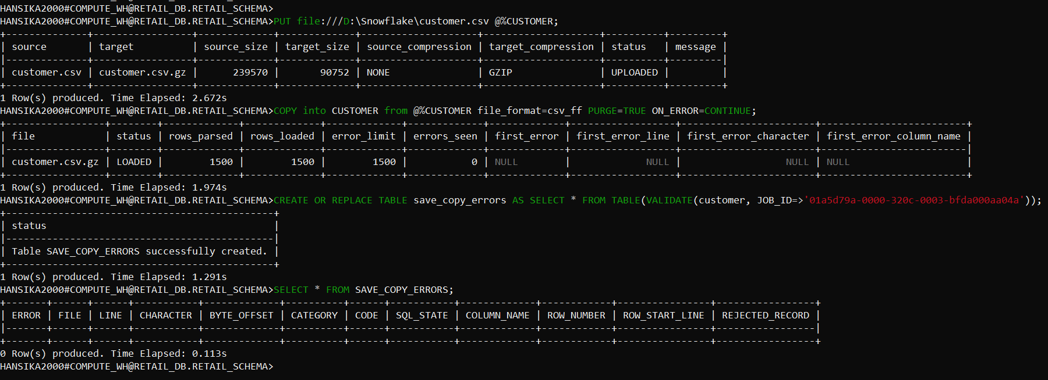

* PUT command is used to upload the files on local machine to the respective stages for the tables lineitem and customer.
* [COPY INTO <table>](https://docs.snowflake.com/en/sql-reference/sql/copy-into-table.html) loads data from the table stage using the named csv_ff file format into table
* The [VALIDATE](https://docs.snowflake.com/en/sql-reference/functions/validate.html) table function is used to view all errors encountered during the previous load.
* PURGE=TRUE is used to purge all files that are successfully loaded into the table
* ON_ERROR = CONTINUE continues to load the file with valid data if errors are found.

1. **LOADING orders table from user stage**

In the below step, we have loaded the table orders using the user stage.

* Each user has a Snowflake stage allocated to them by default for storing files.
* User stages are referenced using @~
* Unlike named stages, user stages cannot be altered or dropped
* User stages do not support setting file format options. Instead, you must specify file format and copy options as part of the [COPY INTO <table>](https://docs.snowflake.com/en/sql-reference/sql/copy-into-table.html) command

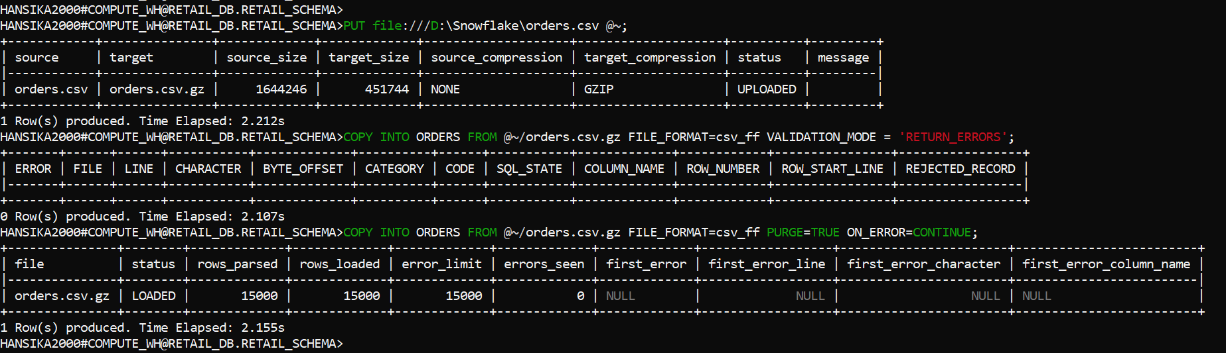

* PUT command is used to upload a file named orders.csv on local machine to the user stage.
* [COPY INTO <table>](https://docs.snowflake.com/en/sql-reference/sql/copy-into-table.html) loads data from your user stage using the named csv_ff file format
* PURGE=TRUE is used to purge all files that are successfully loaded into the table
* ON_ERROR = CONTINUE continues to load the file with valid data if errors are found.

**TASK 5: Load part,partsupp,region and supplier csv files into AWS S3 bucket**

**Snow_extstage.**

1. To upload the csv files first we will go to upload ,

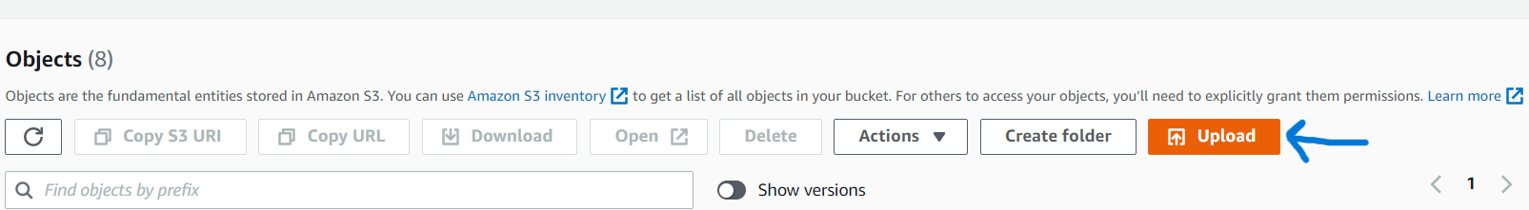

1. Then we will go to Add Files to choose the csv file from our local drive,

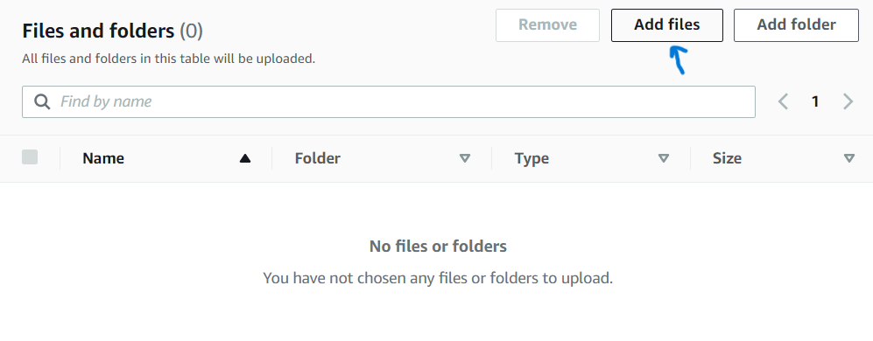

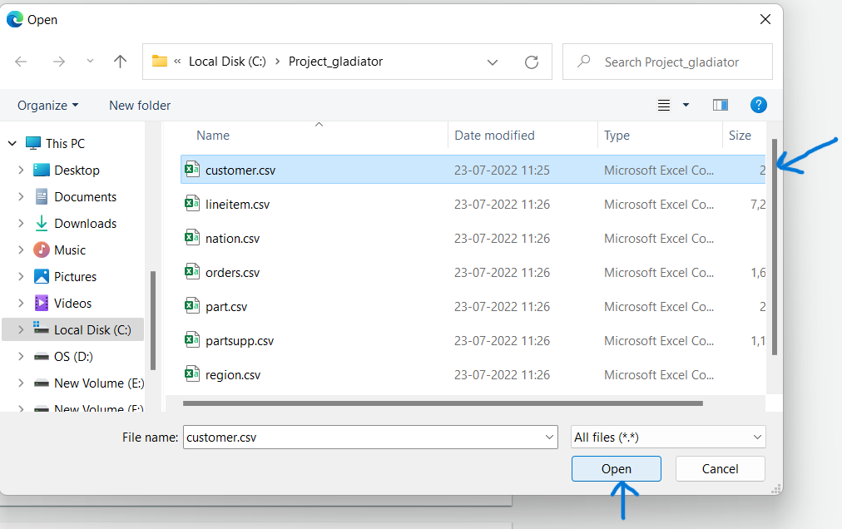

1. Then go to upload and upload it,

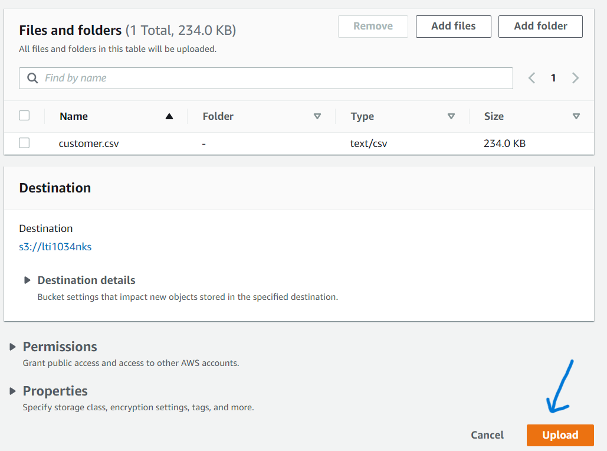

**Like this,**

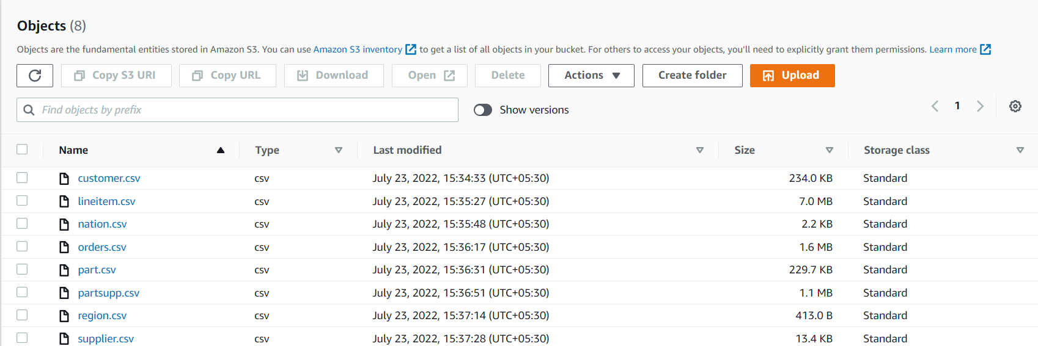

**TASK 6: LOAD DATA FROM EXTERNAL STAGE(AWS S3)**

**&**

**TASK 7: Perform bad records filtering on loading ,file format and compression**

* **Creating storage integration**

In the below step we have created a new storage integration named s3_int1. This allows users to avoid supplying credentials when creating stages or when loading or unloading data.

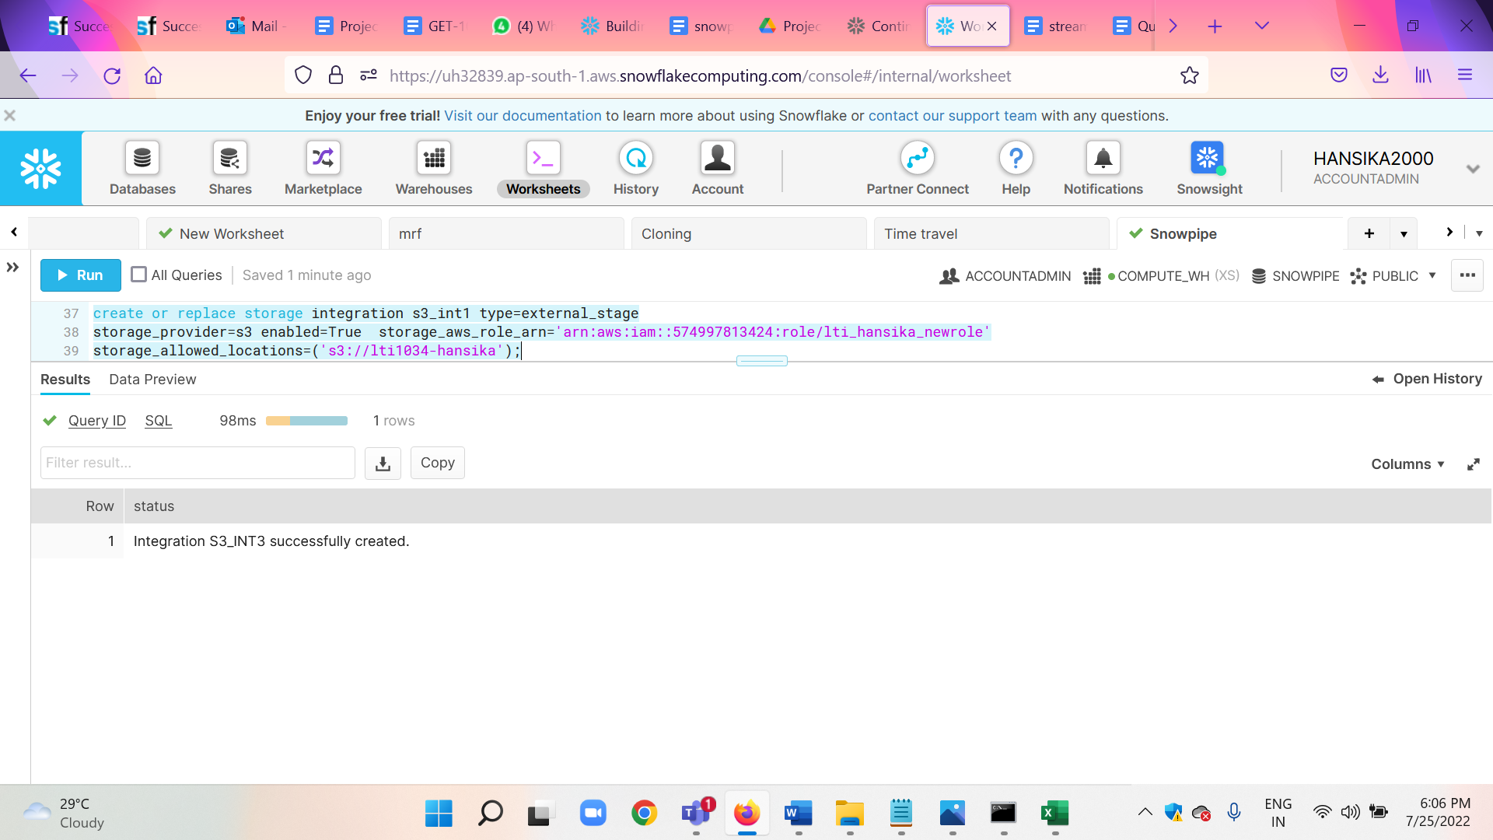

* TYPE = EXTERNAL_STAGE : Specifies the type of integration. EXTERNAL_STAGE creates an interface between Snowflake and an external cloud storage location.
* STORAGE_PROVIDER = S3 : Specifies the cloud storage provider that stores the data files.
* ENABLED = TRUE: Specifies whether this storage integration is available for usage in stages. TRUE allows users to create new stages that reference this integration.
* STORAGE_AWS_ROLE_ARN = *iam_role* : Specifies the Amazon Resource Name (ARN) of the AWS identity and access management (IAM) role that grants privileges on the S3 bucket containing the data files.
* STORAGE_ALLOWED_LOCATIONS = ('*cloud_specific_url*') : This value includes a cloud storage URL where required files are present
* **Creating external stage**

In the below step we have created an external stage named my_external_stage that references a S3 bucket.

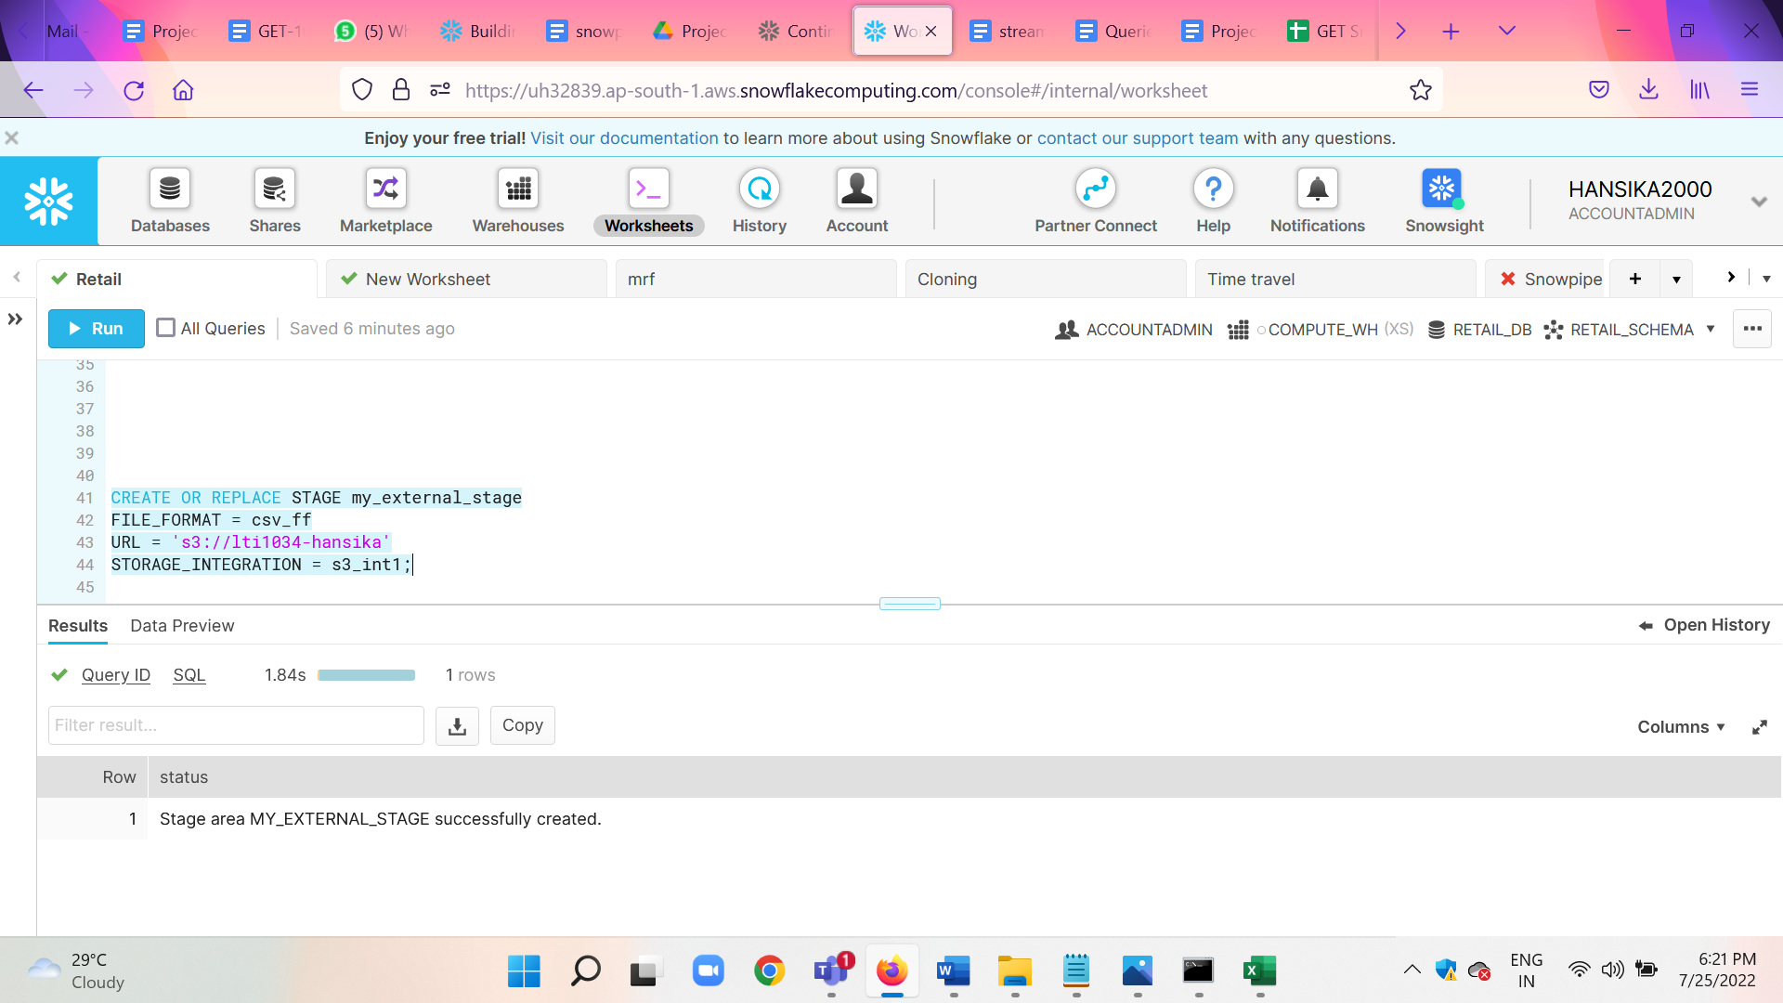

* FILE_FORMAT : A file format named csv_ff created earlier is used
* URL: The cloud storage URL specifies the storage location of the required files
* Storage_Integration: Secure access to the S3 bucket is provided via the s3_int1 storage integration.
* Loading from external stage
* Snowflake supports transforming data while loading it into a table using the [COPY INTO <table>](https://docs.snowflake.com/en/sql-reference/sql/copy-into-table.html) command. Column reordering, column omission, and casts can be performed using a [SELECT](https://docs.snowflake.com/en/sql-reference/sql/select.html) statement.
* LTRIM() removes leading characters, including whitespace, from a string. In our case, this function is used to trim the strings (eg: from ‘Manufacturer#1’ to ‘1’)
* ON_ERROR = CONTINUE continues to load the file with valid data if errors are found.
* FORCE = TRUE is specified as one of the copy options, so that the command does not ignore the staged data files that were already loaded into the table.

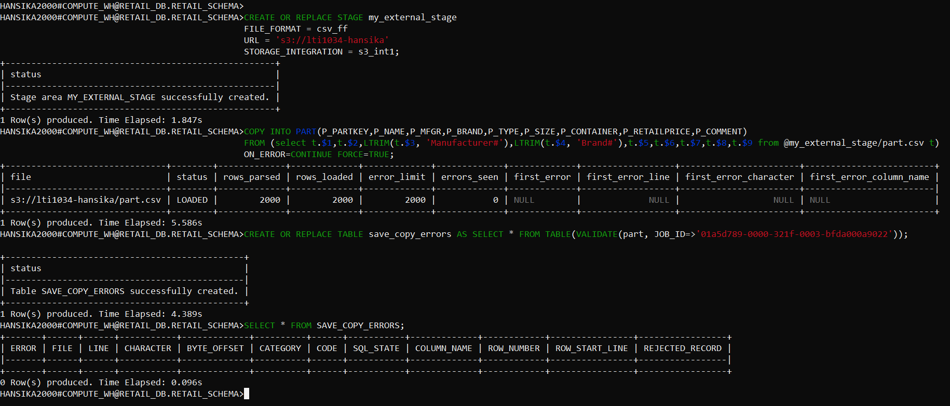

Hence, the part table is loaded using an external stage which loads data from the s3 bucket.

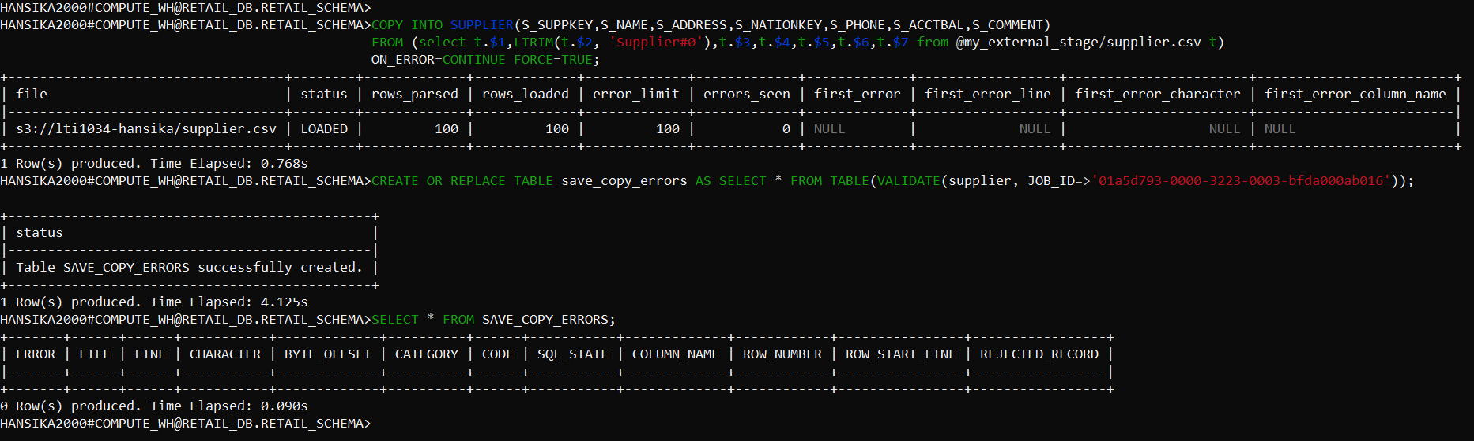

Hence, the supplier table is loaded using an external stage which loads data from the s3 bucket.

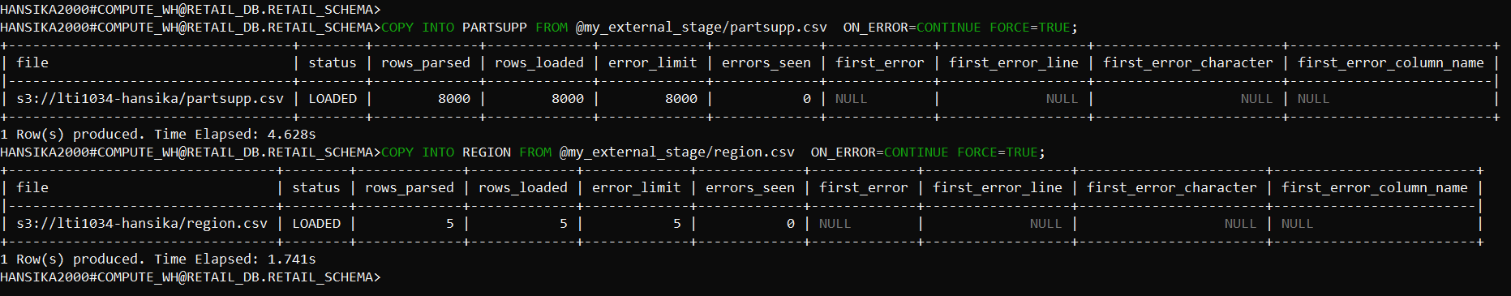

Hence, the partsupp and region tables are loaded using an external stage which loads data from the s3 bucket.

**TASK 8:** Create snowpipes to continuously load orders data from external stage from S3

bucket to the order staging table, maintain the change data capture and merge

the data to the consumption table.

1. To see the details of the storage integration use the following command

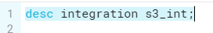

1. Create IAM role : to get arn

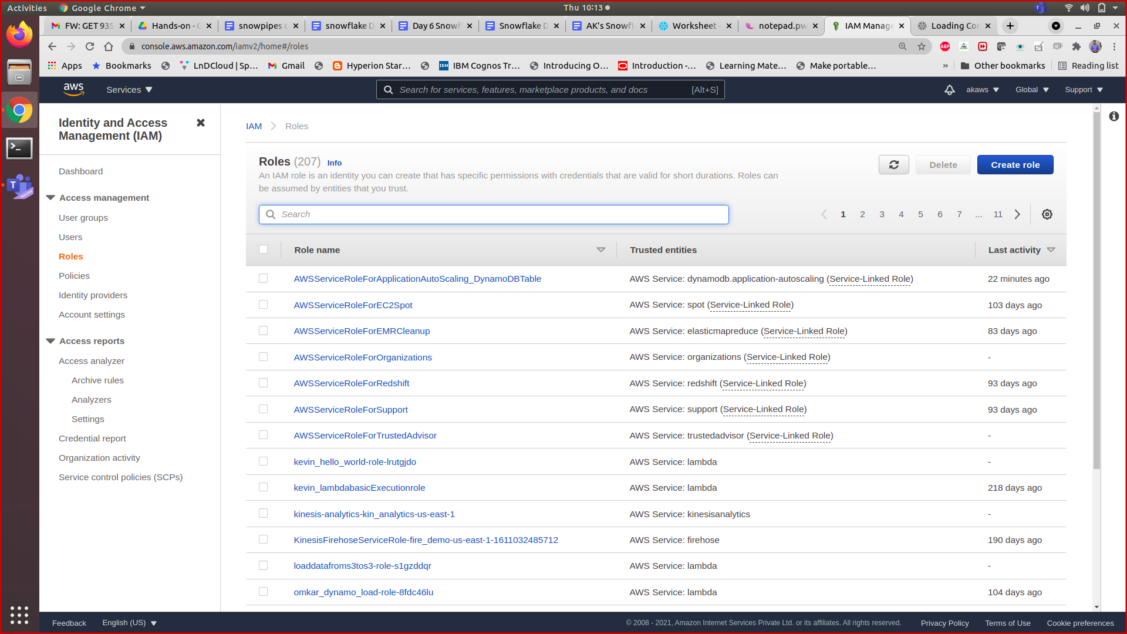

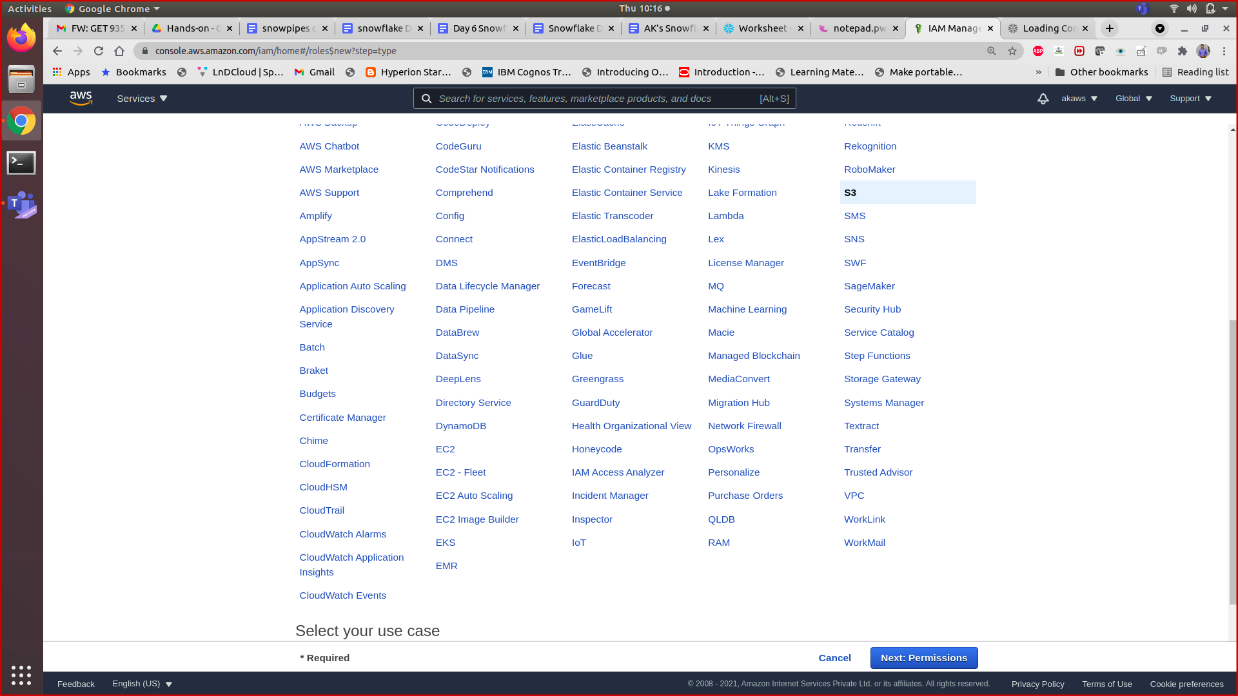

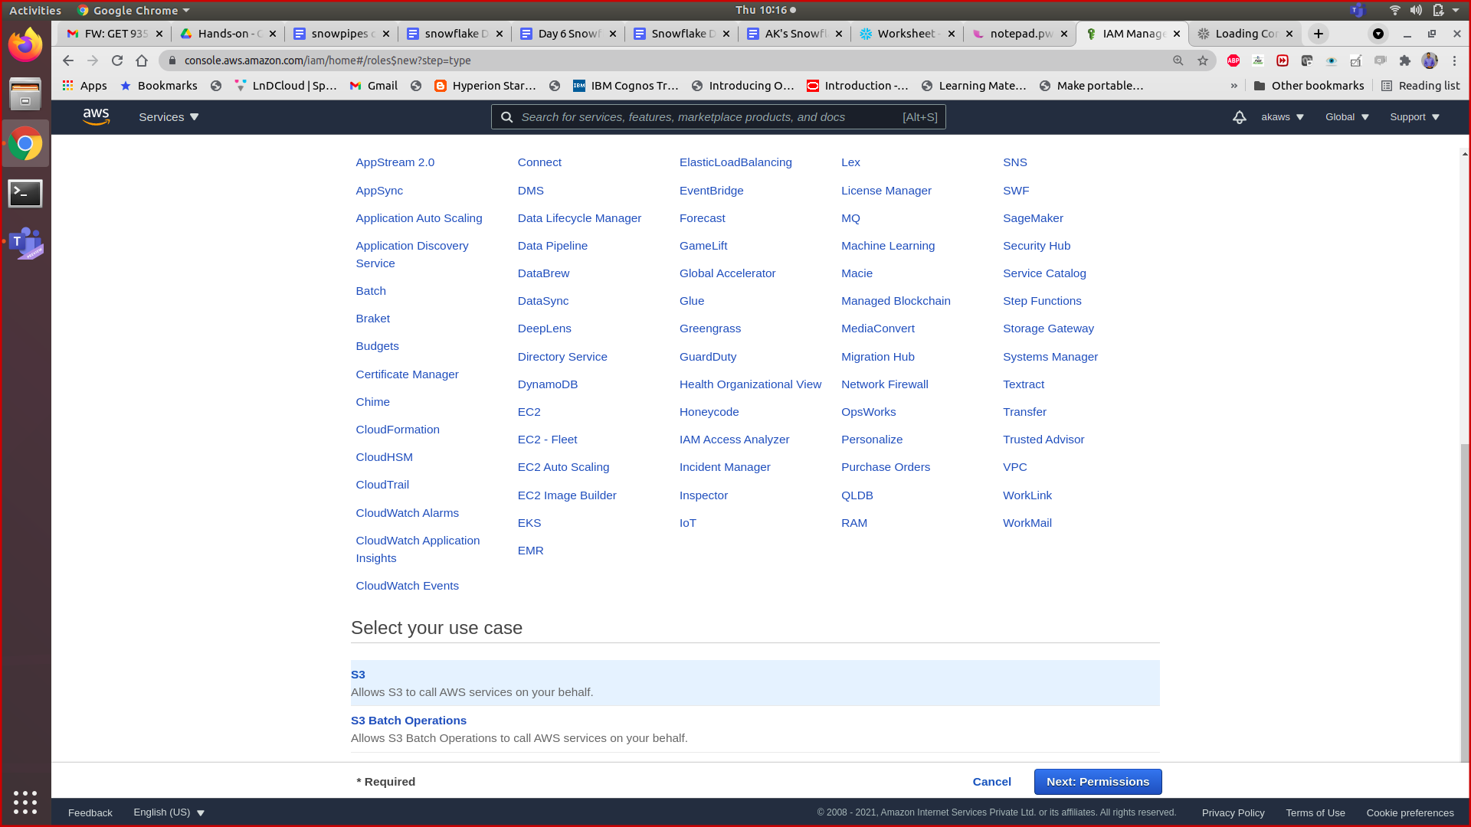

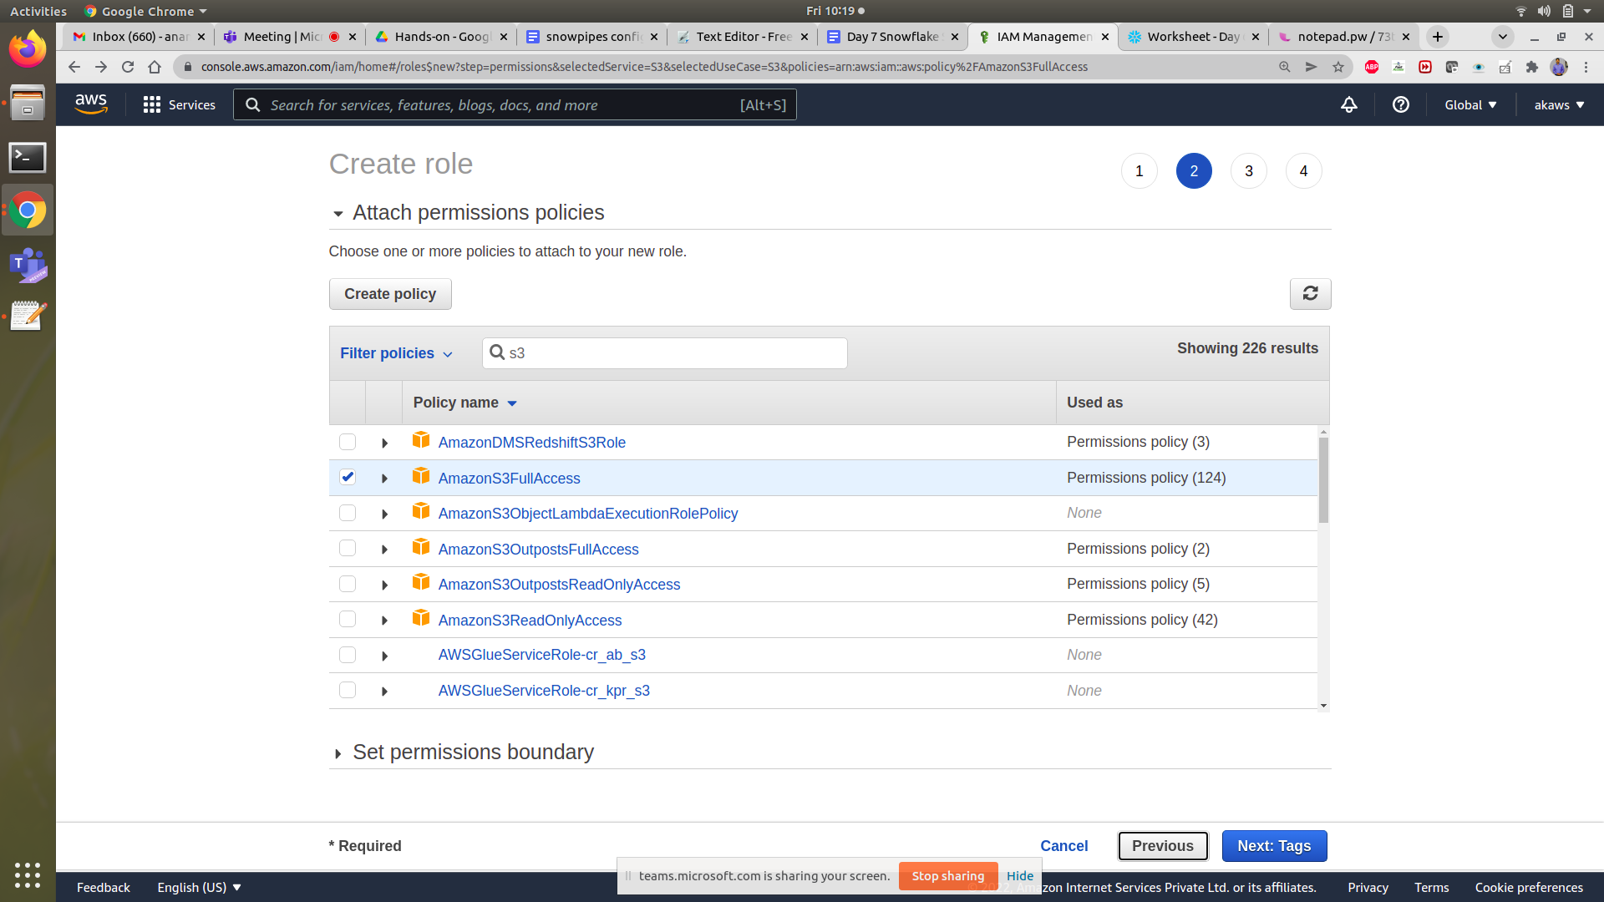

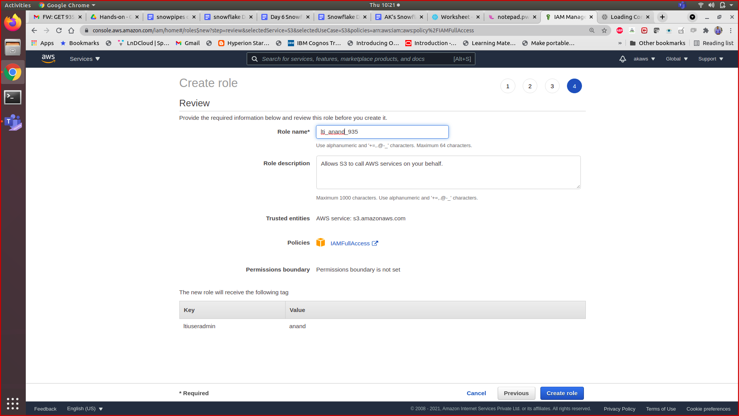

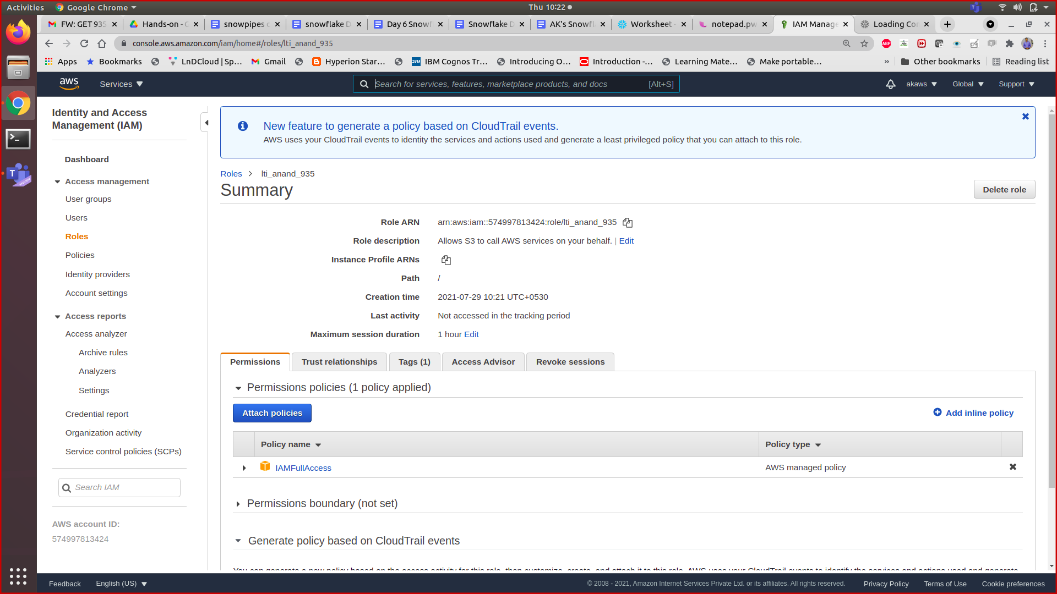

1. create storage integration with iam arn

create storage integration s3_int

type = external_stage

storage_provider = s3

enabled = true

storage_aws_role_arn = 'arn:aws:iam::<arn_id>:role/<rolename>'

storage_allowed_locations = ('s3://<bucketlocation>');

Desc integration s3_int;

1. Add the trusted relationship

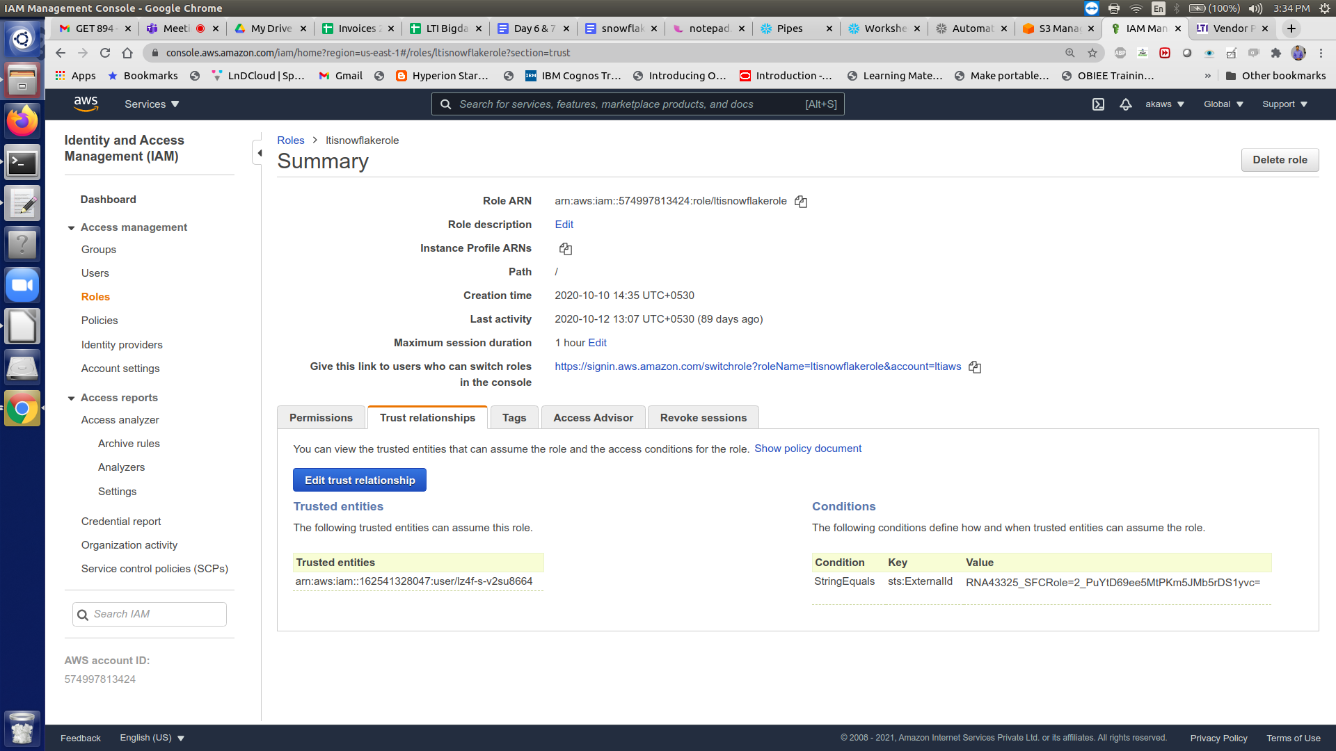

1. run desc integration command in snowflake worksheet and get the snowflake arn and external id , replace it IAM role trusted relationship policy document .

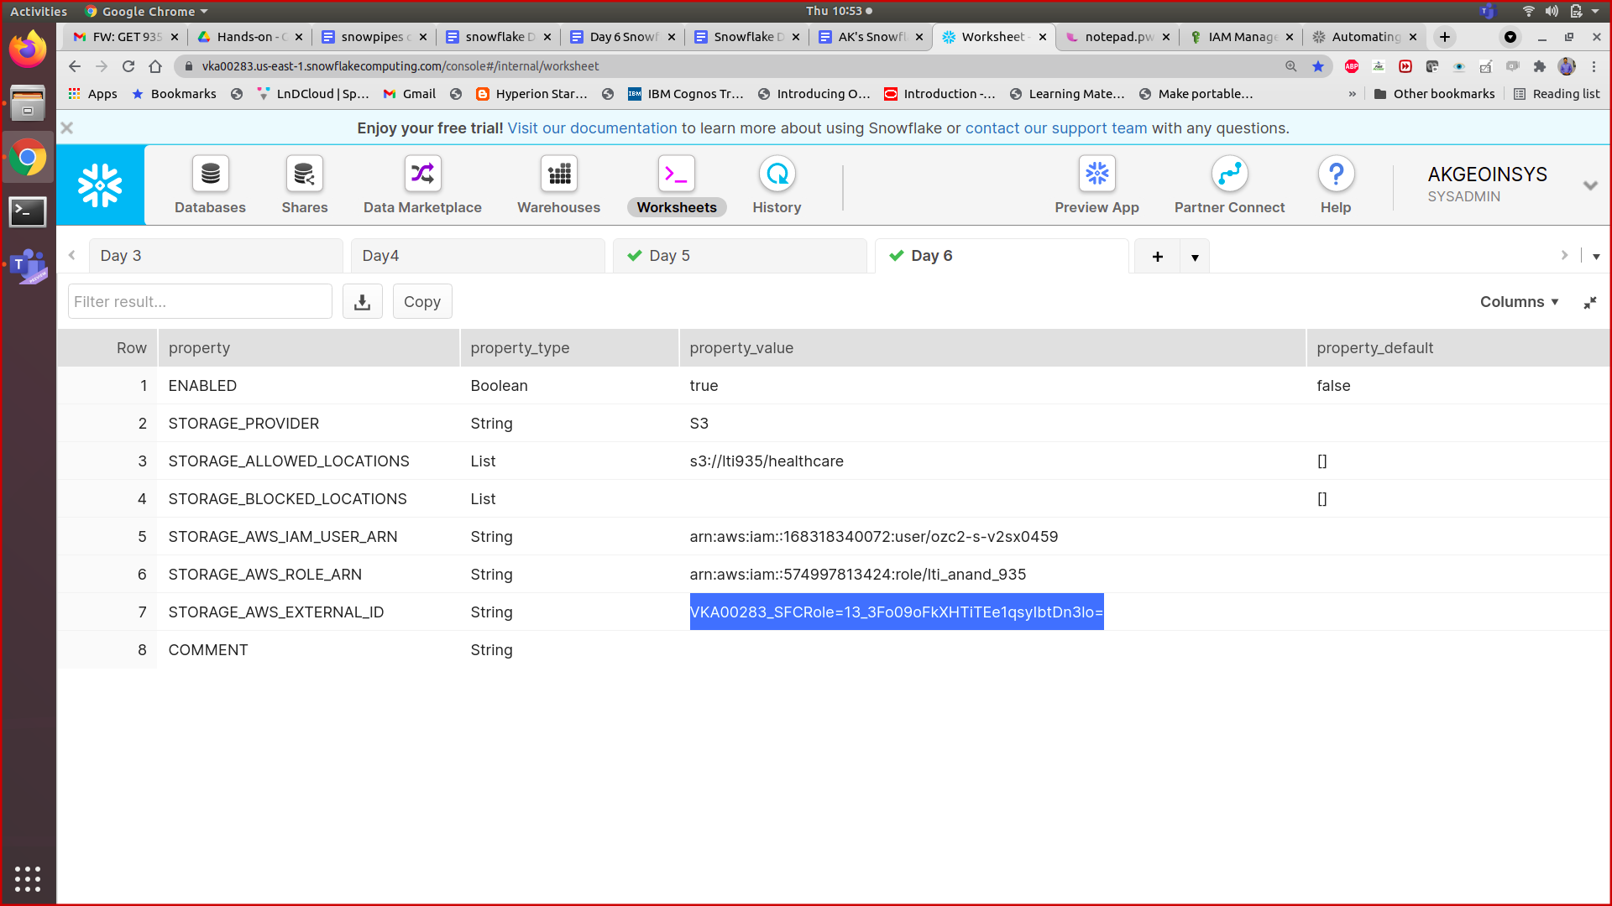

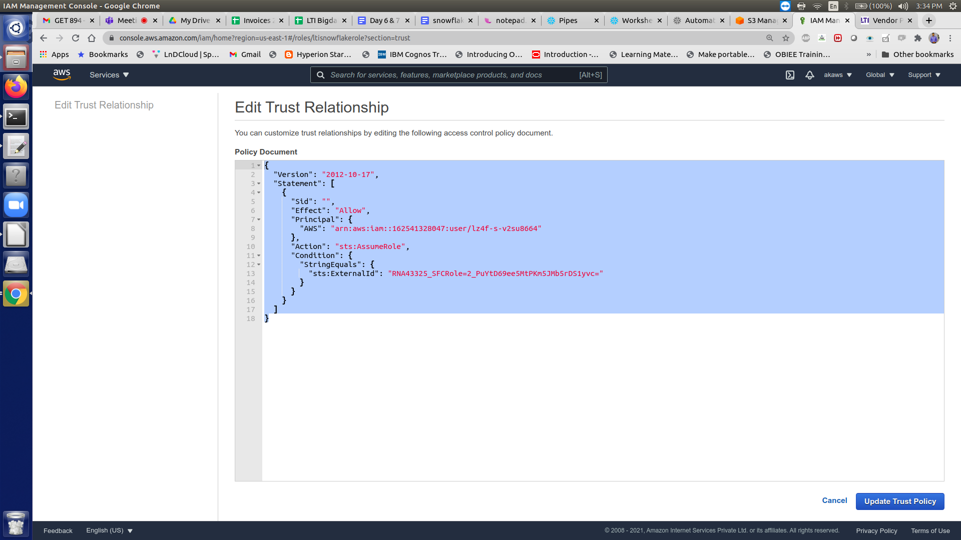

{

**"Version":** "2012-10-17",

**"Statement":** [

{

**"Sid":** **""**,

**"Effect":** **"Allow"**,

**"Principal":** {

**"AWS":** "<snowflake_user_arn>"

},

**"Action":** "sts:AssumeRole",

**"Condition":** {

**"StringEquals":** {

"sts:ExternalId": "<snowflake_external_id>"

}

}

}

]

}

1. Use the external id and snowflake arn from desc integration s3_int;

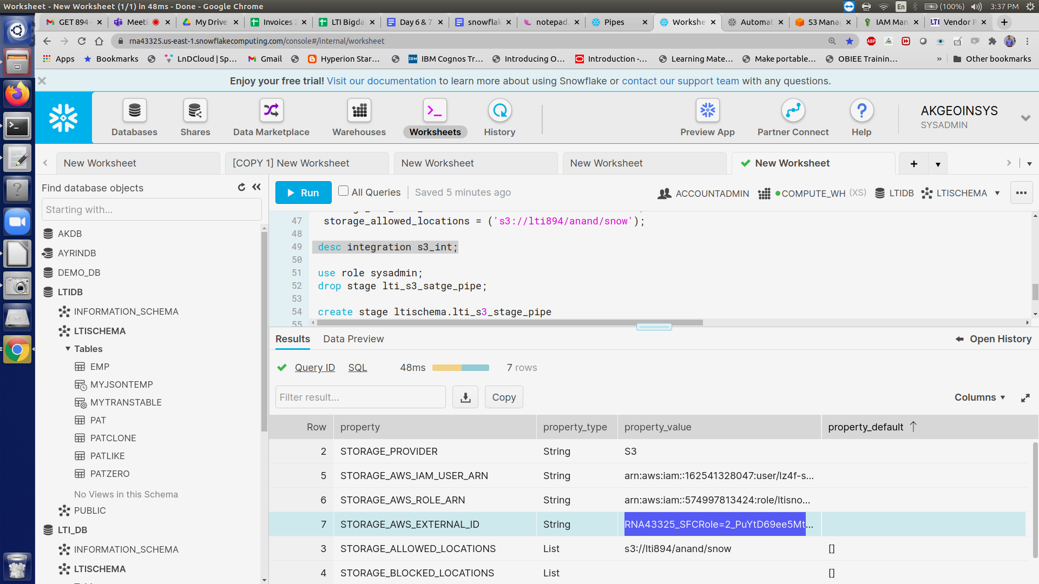

1. Create the external stage for s3 with integration
2. Create the pipe and map source and destination
3. In s3 bucket , create the event notification snowflake with sqs which you get as notification channel from command Show pipes :
   1. Create event in s3 bucket

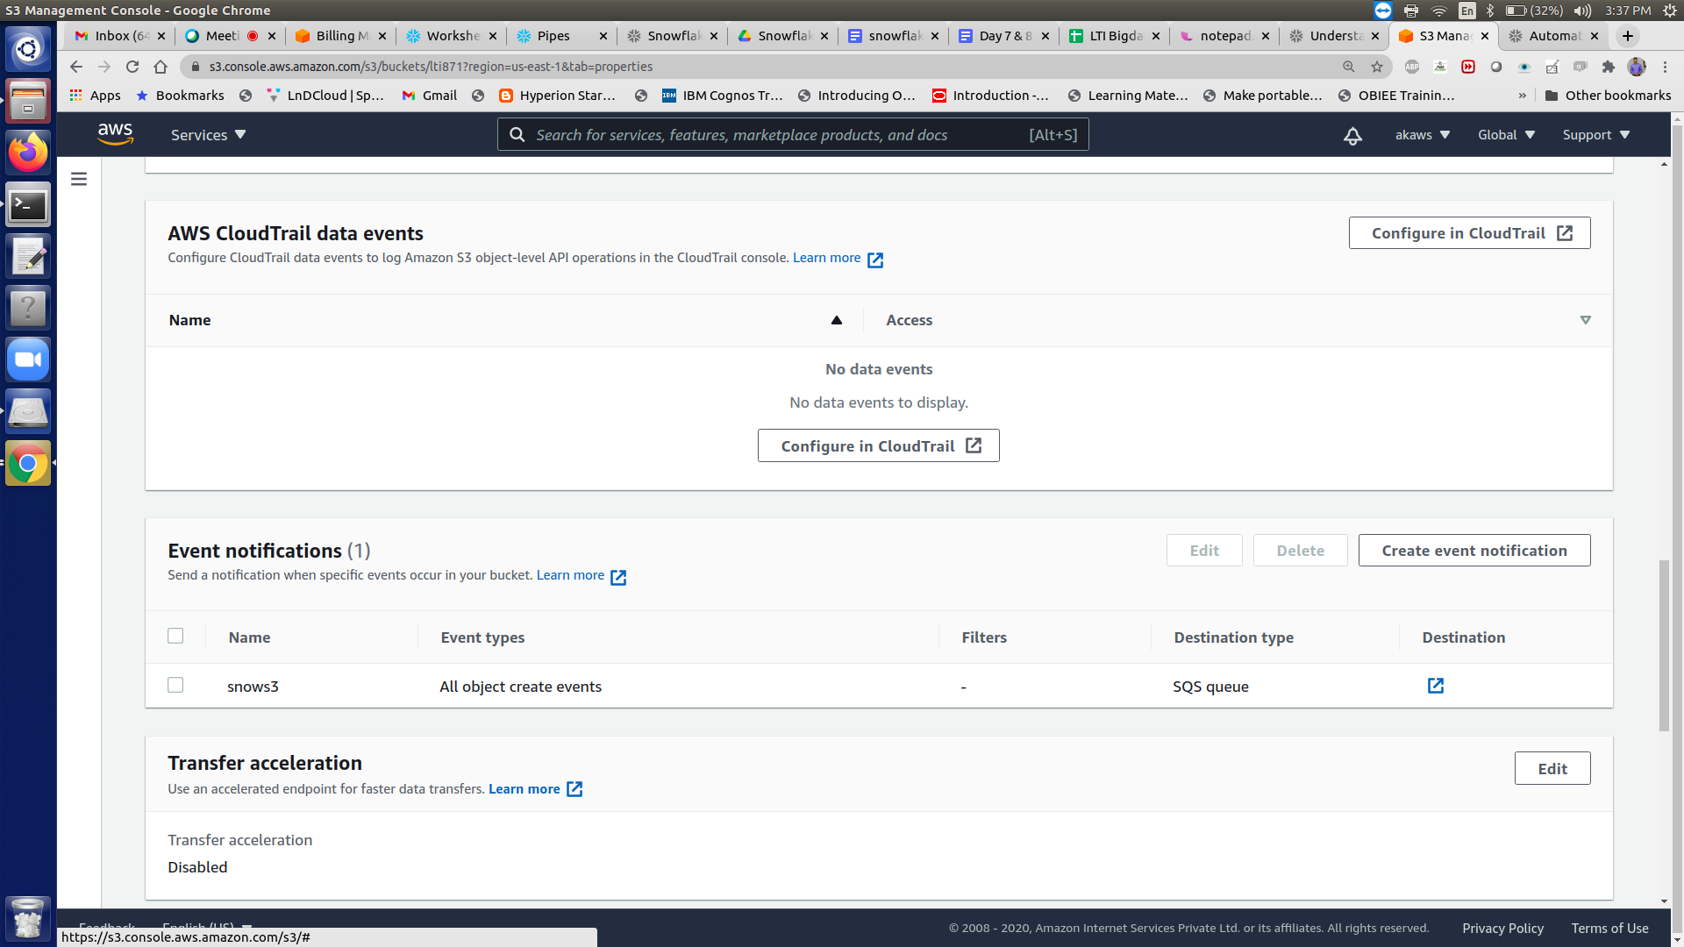

* 1. Select all object creation

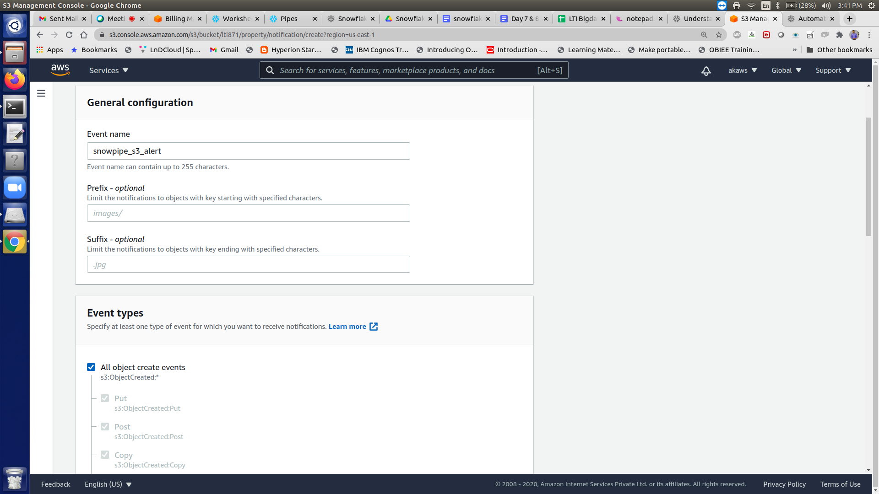

* 1. Log into the Amazon S3 console.
     1. Configure an event notification for your S3 bucket using the instructions provided in the [Amazon S3 documentation](https://docs.aws.amazon.com/AmazonS3/latest/user-guide/enable-event-notifications.html). Complete the fields as follows:

**Name**: Name of the event notification (e.g. Auto-ingest Snowflake).

**Events**: Select the **ObjectCreate (All)** option.

**Send to**: Select **SQS Queue** from the dropdown list.

**SQS**: Select **Add SQS queue ARN** from the dropdown list.

**SQS queue ARN**: Paste the SQS queue name from the SHOW PIPES output.

* + 1. snow pipe auto ingest the data from s3 bucket when you create or copy file to the stage location.

1. Create the table CDC_Orders and Orders_History to track the CDC(Changing Data Capture) and the Historical records respectively. They are created as follows

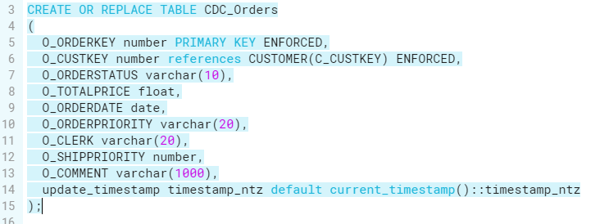

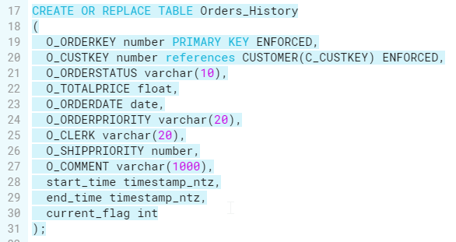

Note that the default constraint is not of much use because it only works when data is inserted using SQL commands, and Snowflake is not designed to let the default constraint work with data loading from snowpipe, and so the update_timestamp will show NULL until manual updates are done on the table. To tackle this issue we can ask the team to track the timestamp of updates as well.

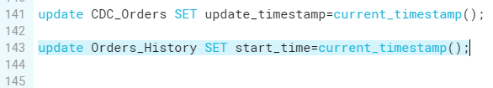

Hence we manually update the current timestamp in CDC_Orders and Orders_History.

1. Next create a snowpipe as follows

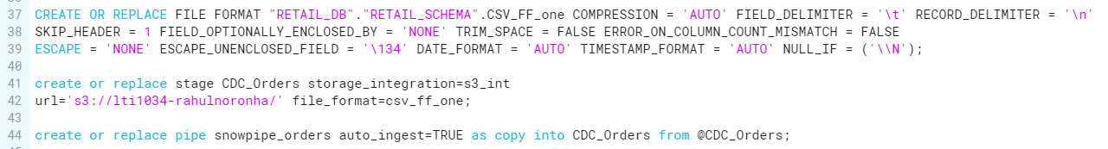

1. Create a stream on the table CDC_Orders which essentially turns CDC on

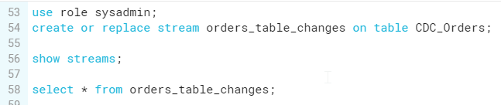

We use role sysadmin to create the stream orders_table_changes.

1. The ORDER_CHANGE_DATA view handles the logic to figure out what needs to be loaded into the ORDERS_HISTORY table. It relies on the data in the ORDERS_TABLE_CHANGES stream.

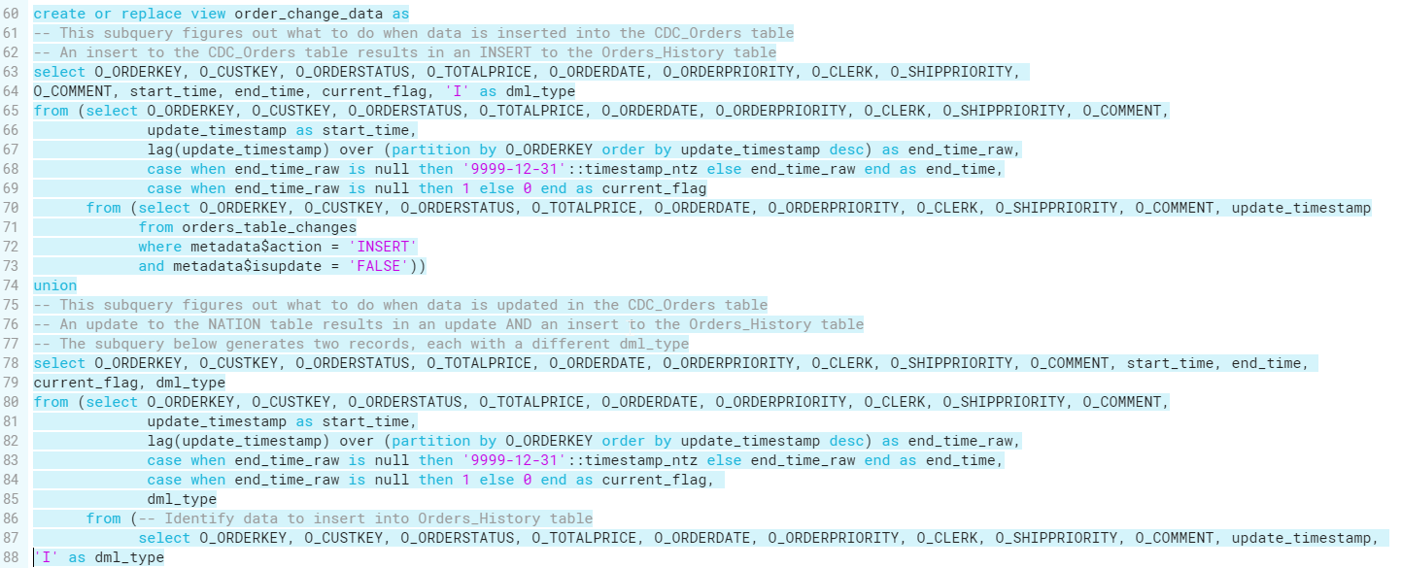

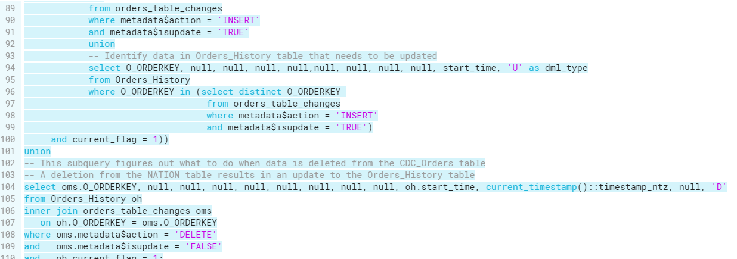

1. When the new data is loaded into snowpipe from orders2507.csv which is uploaded into the s3 bucket lti1034-rahulnoronha the new records are reflected in CDC_Orders table. Use the select query to view the changes in the table.

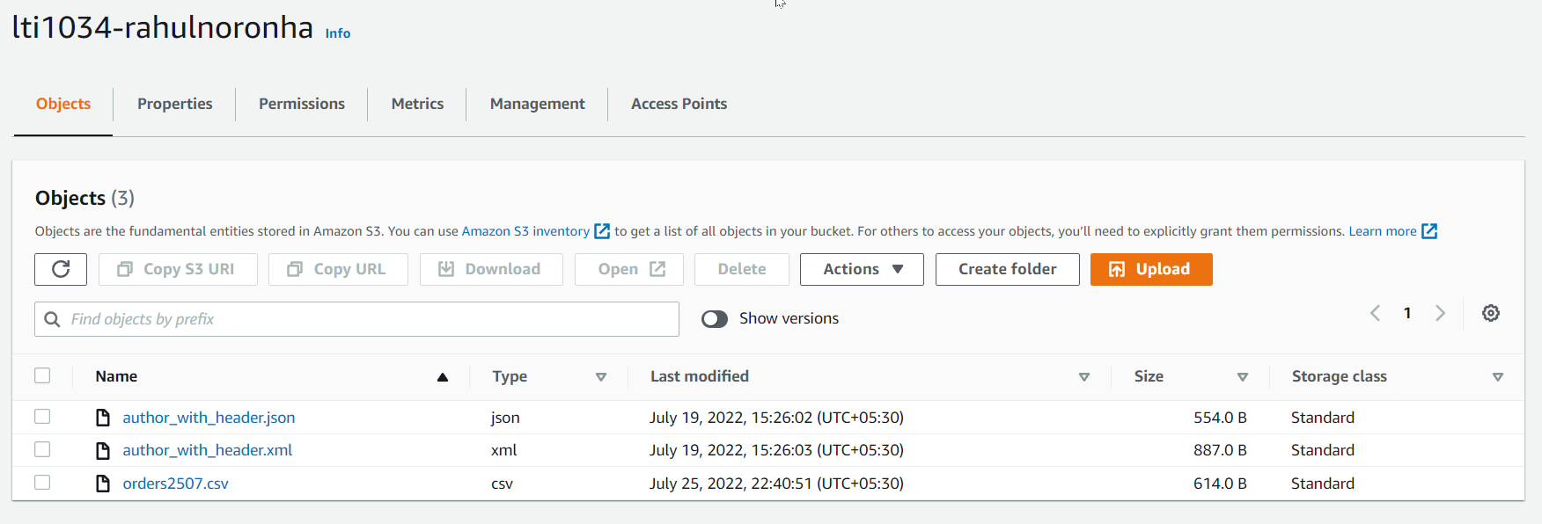

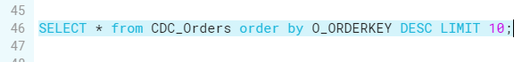

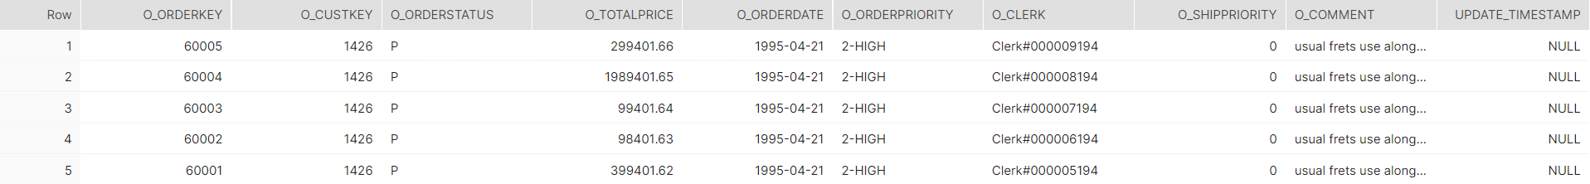

1. Changes to CDC_Orders are captured in the stream and can be viewed as follows

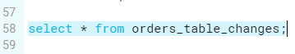

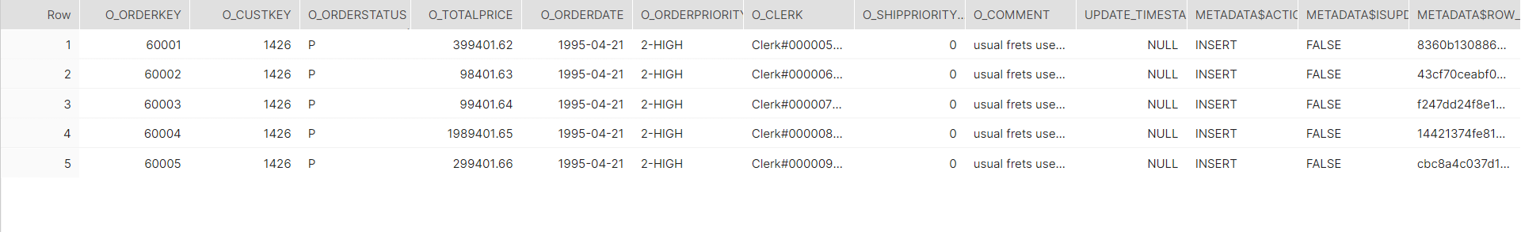

1. Changes are merged to the History table as follows from the stream. We can set up a task every few minutes to perform the merge operation.

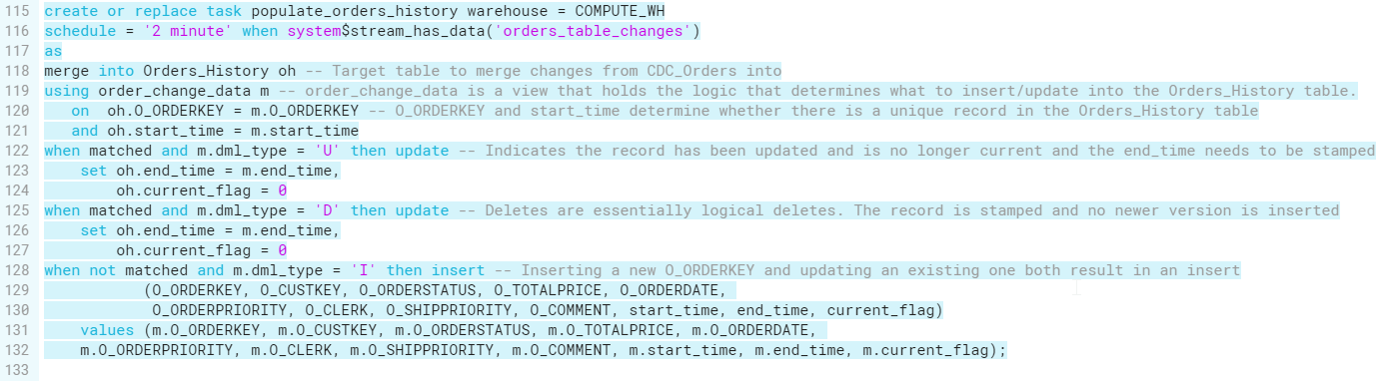

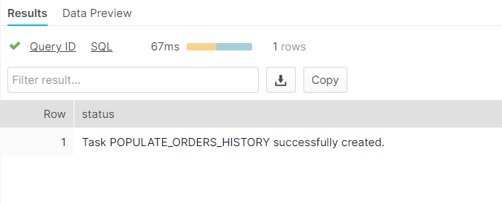

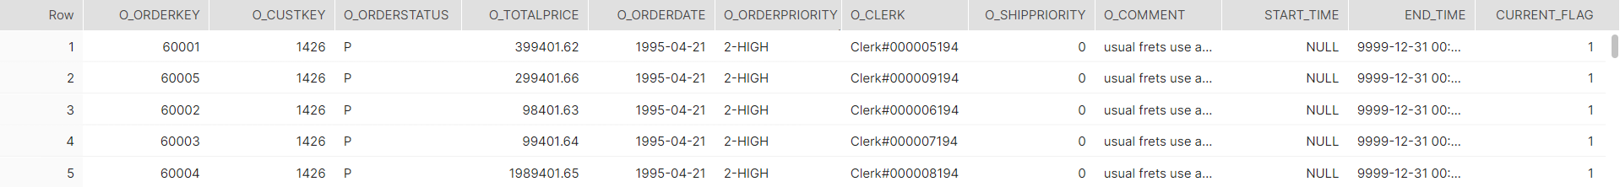

**…….**

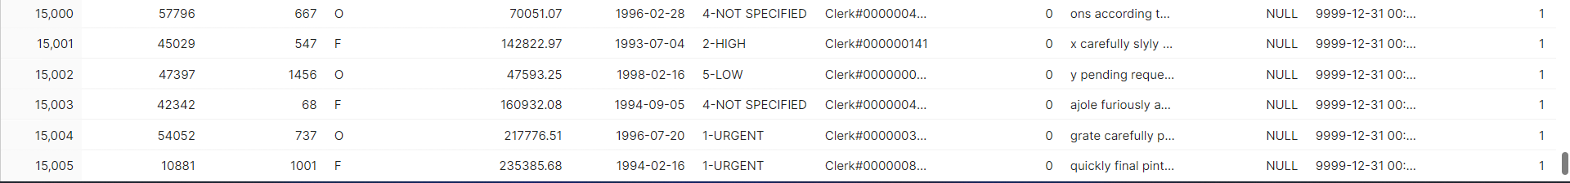

**TASK 9**: Share your table to a new non-snowflake user.

1. So in the provider account first we need to create an outbound share to share the database, table to the consumer and grant access to the database,tables and warehouse.

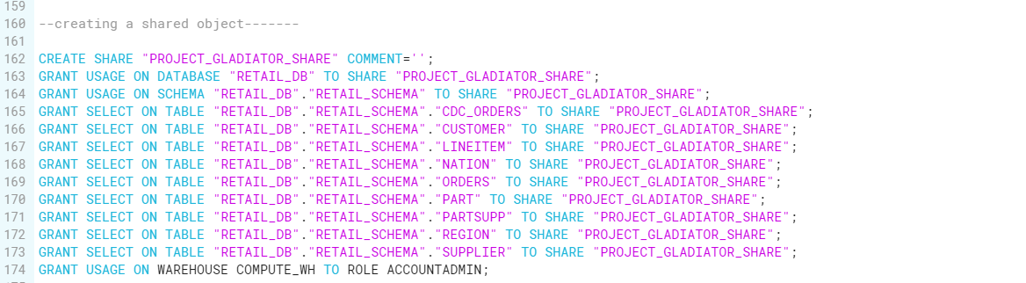

1. Now we need to create a reader account and add it to provider account,

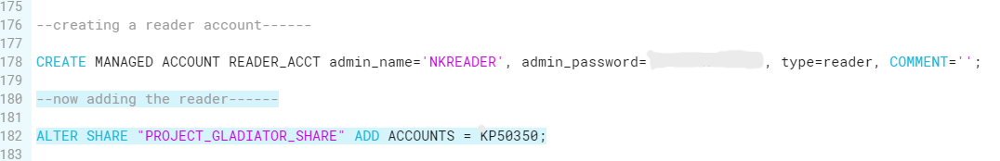

here you can see the reader account is added,

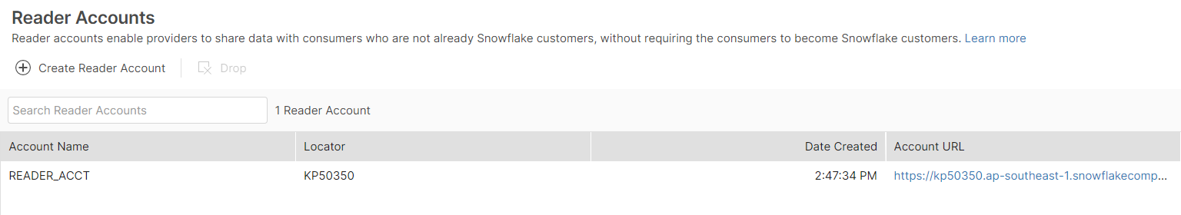

A reader account is intended primarily for querying data shared by the provider of the account. Adding new data to the account and/or updating shared data in the account is not supported.

1. Now login to the reader account and create a warehouse

And we will create a database from secure share in reader account

with the role account admin to consume the shared data,



Then we will grant privileges to roles in the reader account,



Here we can see all the tables in the reader account,

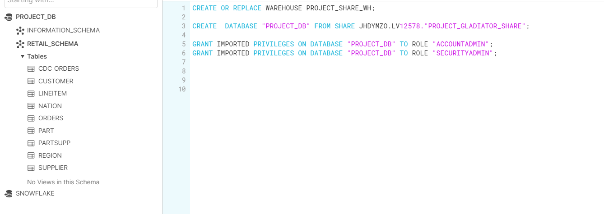

So now we can access the data as you can see here,

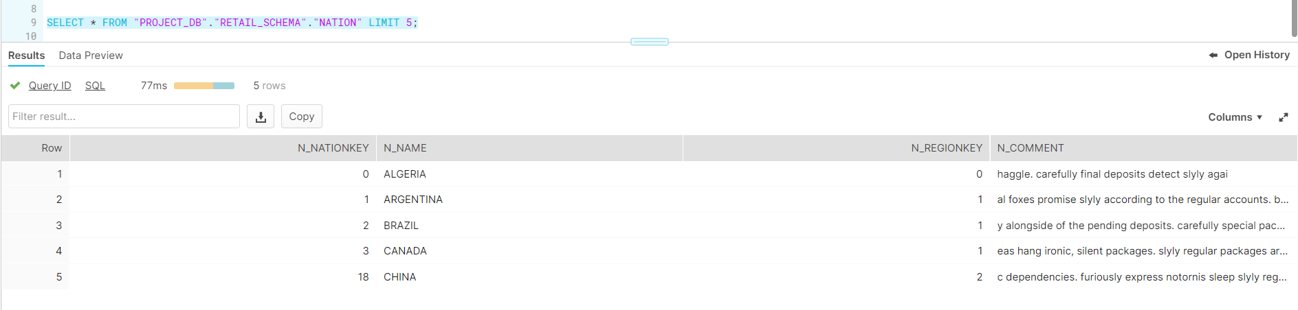

**TASK 10**: Create clone of the table with time travel before one day and write query to get

history data using particular timestamp

These are the ways to perform time travel:

* Using offset
* Using timestamp
* Using statement/query id
* Using Undrop table command

1. Time travel using offset:

To copy into a clone table use CREATE OR REPLACE TABLE clone_name CLONE object_name AT …

We can use the command shown below to travel back in time to retrieve a table. Here use the AT or BEFORE keywords to specify that we want to go back in time. In the bracket we give offset=>-60*60*24. The negative symbol signifies we are going back in time and the value is in seconds, hence we use the number of seconds in a day=60*60*24 to go back 24 hours or 1 day.



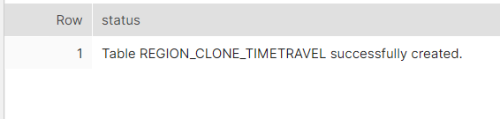

We use the select command to view the cloned table in the past.

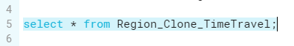

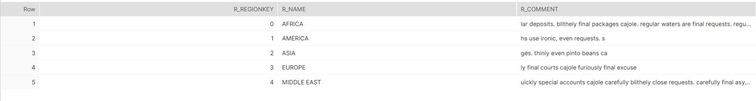

1. Time Travel using timestamp:

Here we first insert a new record into the Region table using insert into command.



We see the newly inserted table will have our inserted row using select * command from Region.

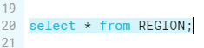

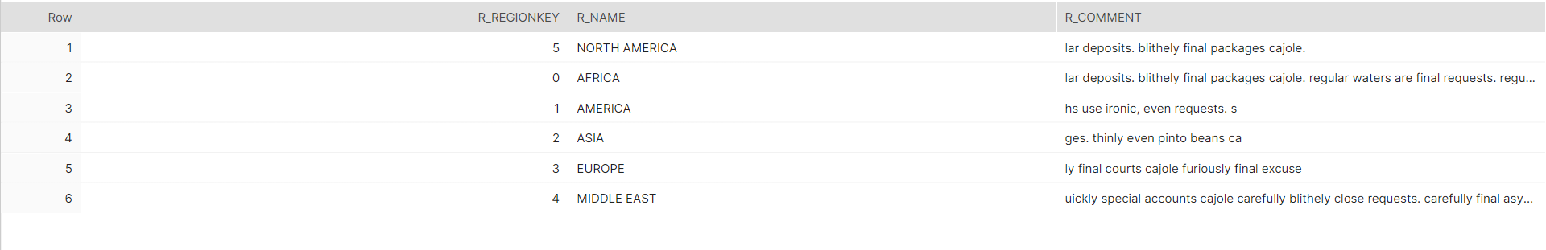

To clone the table into the Region_History_TimeTravel table at the timestamp before we insert the new record we check the query history and get the timestamp. Then we add it in the brackets as timestamp=>TO_TIMESTAMP(‘2022-07-26 00:23:12.915’))

Here we use the TO_TIMESTAMP to convert the string into a timestamp data type.



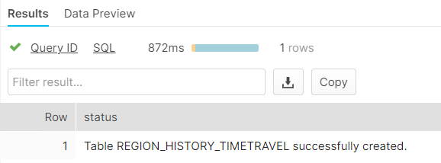

We can view this cloned table using select * to retrieve the table before the new row was inserted.



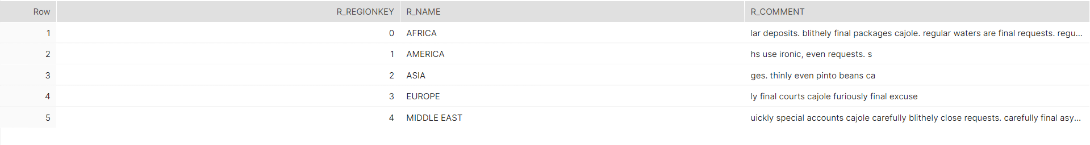

1. Time Travel using Query ID

We can time travel using the query id of a past command by finding its query id from the history tab in Snowflake.

First we delete a row from the table Region. We notice the select * query of Region returns only 5 rows now, since the newly inserted record in the previous step has been deleted.

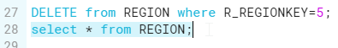

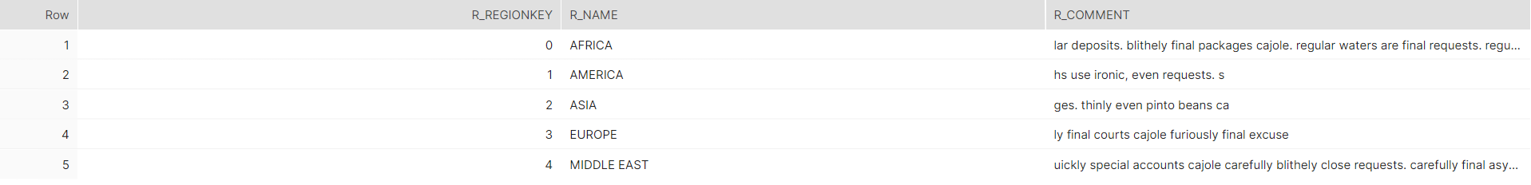

To get the table before the delete query we use the following command



Select * Region table now shows 6 records since we restored the deleted record using time travel.

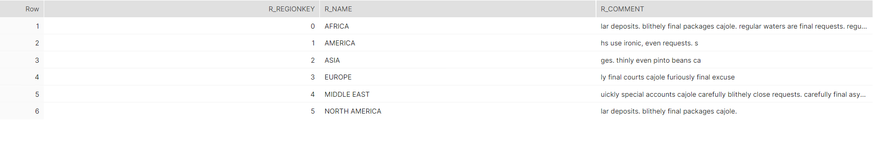

1. Undrop table:

We can restore a table we have dropped using the undrop command as follows.

First we drop the table using DROP TABLE Region;

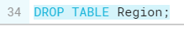

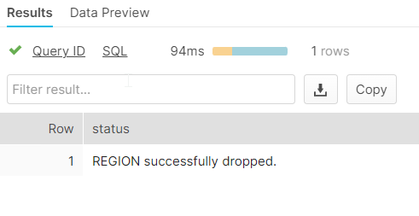

Once the table is dropped we can’t view it using select * from Region.

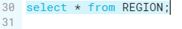

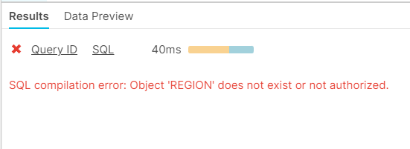

Use the UNDROP option on the table to restore it

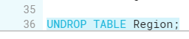

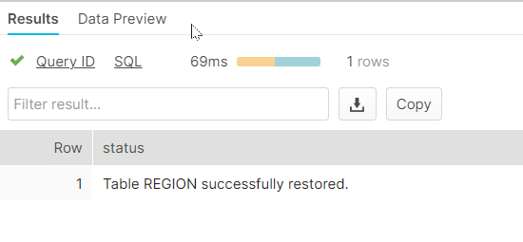

Now when we call select * from Region we will be able to see the table values restored.

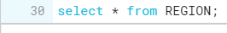

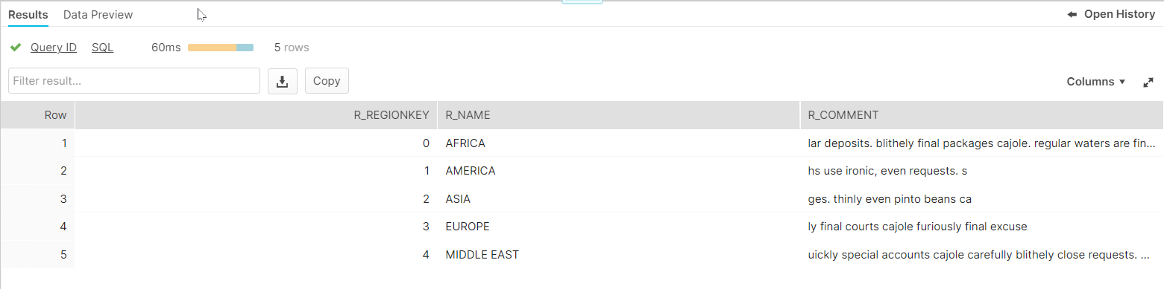

**TASK 11**: **Create stored procedure to insert data into table after typecasting date format**

In the below step, a stored procedure named date_format is created.

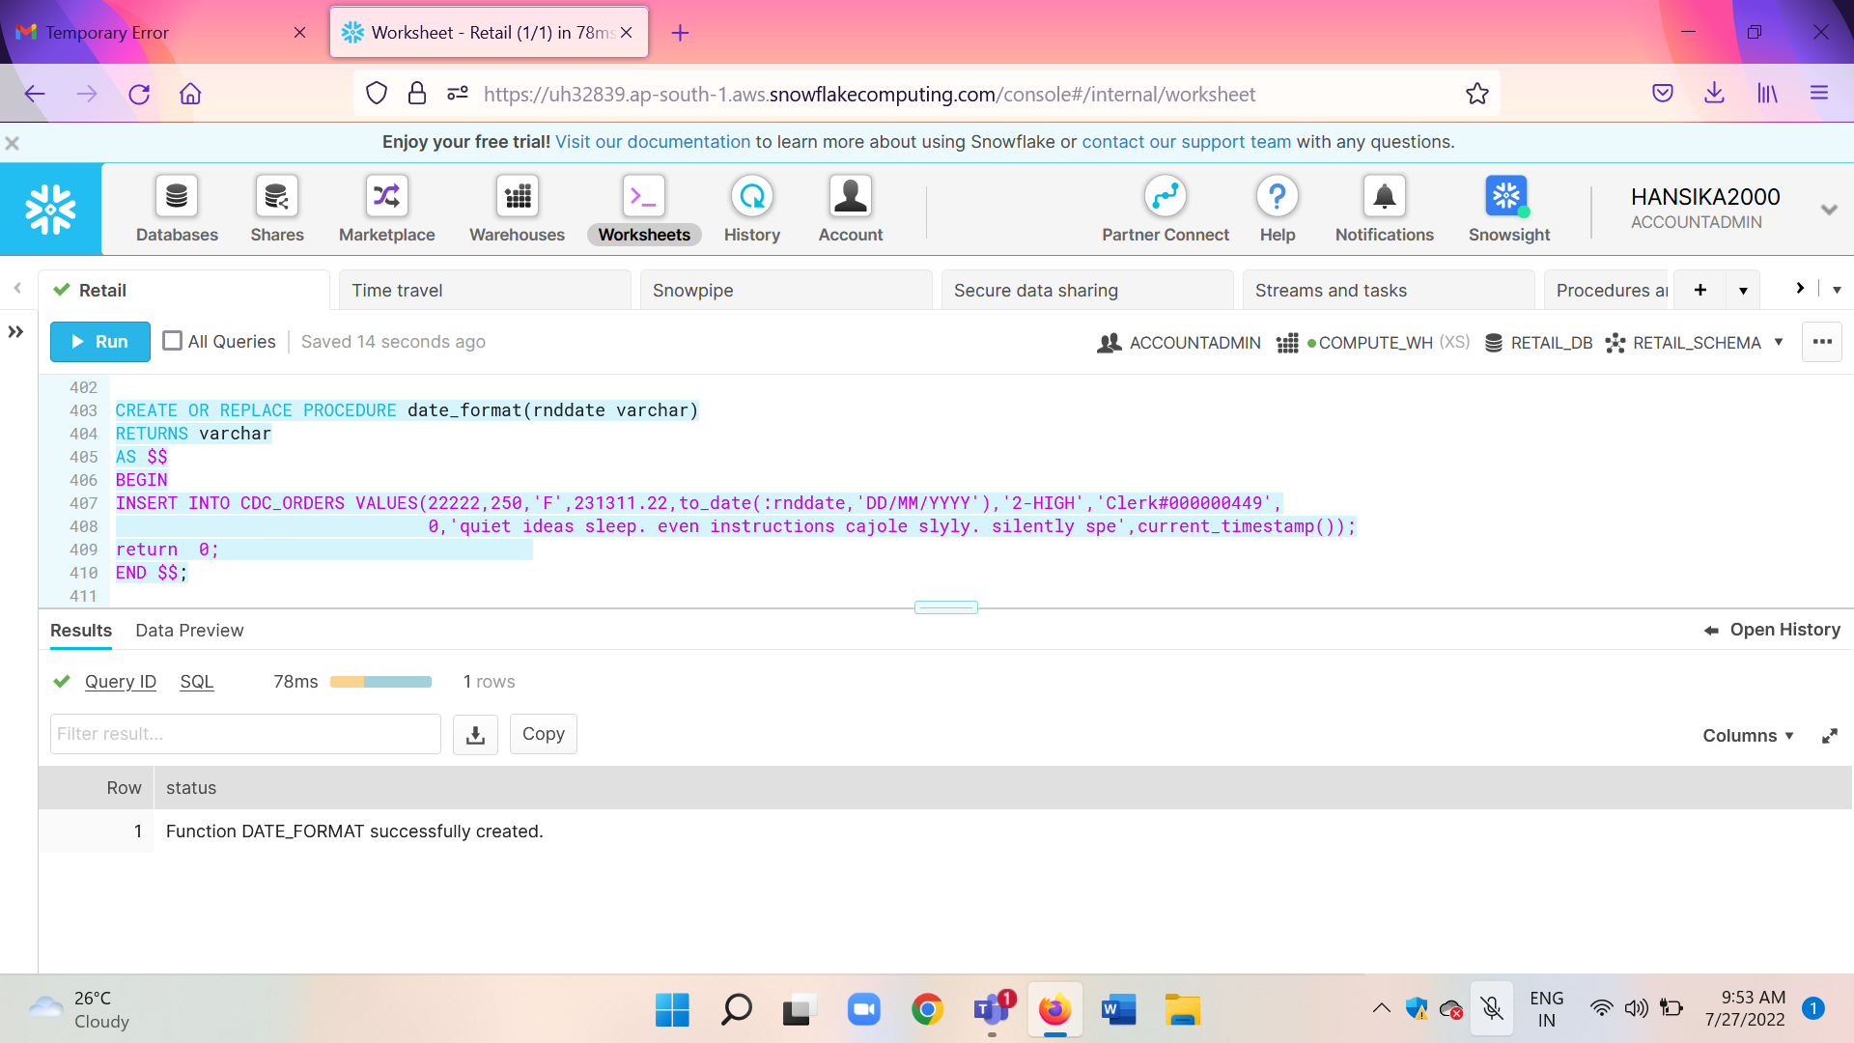

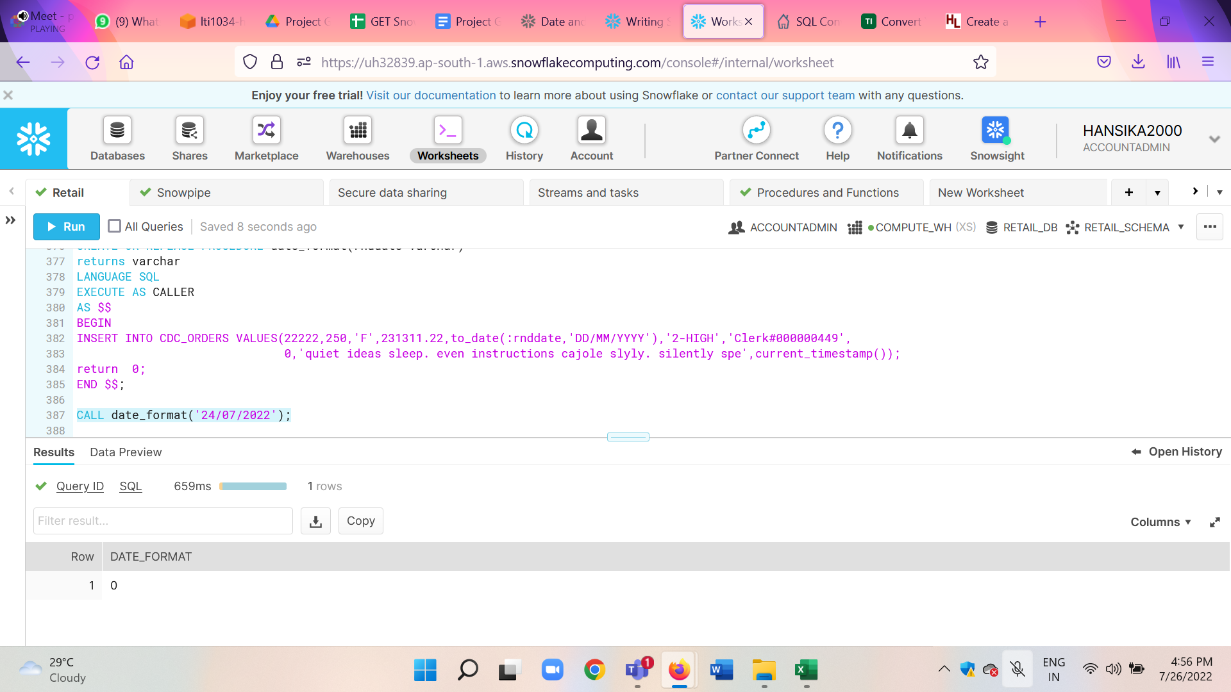

In the above step the procedure date_format is called. The procedure, when called, inserts a new record into the table CDC_ORDERS after typecasting the date provided in the procedure call.

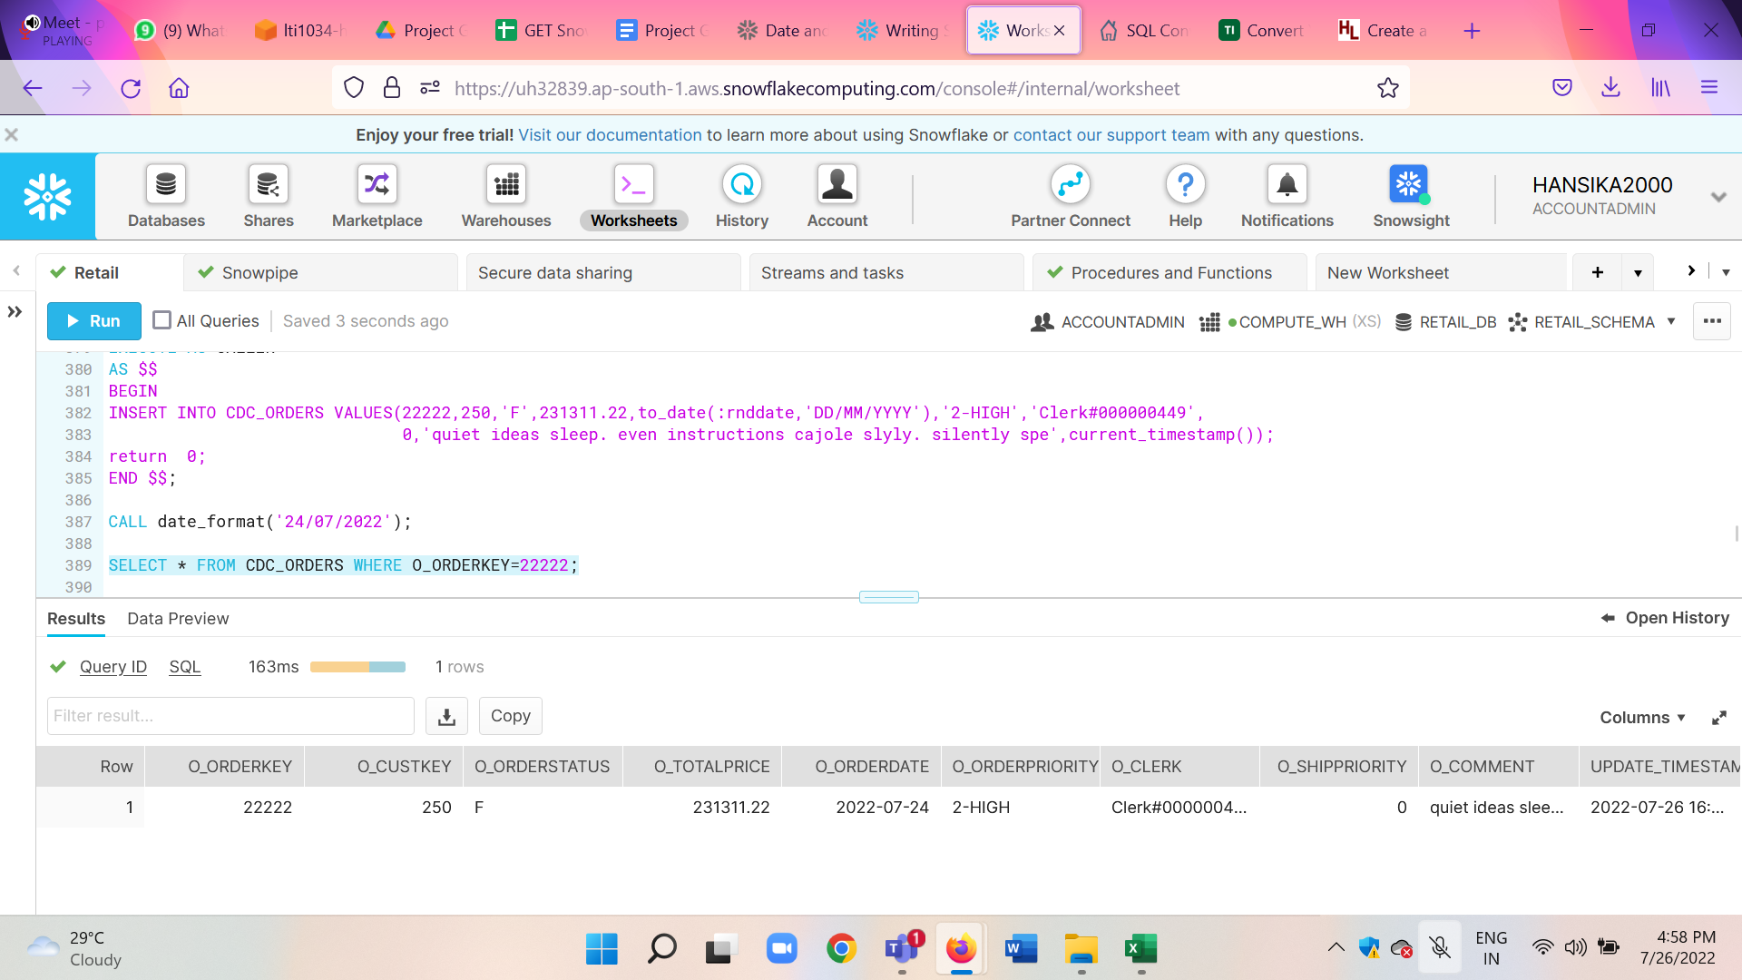

As we can see that the record got inserted.

**TASK 12**:Create a visualization for sales performance analysis using powerBI and prepare

reports /dashboard for business queries

1. **Snowflake:**

We find the maximum and the minimum l_shipdate and since we get 1998-11-29 as the maximum, we can use it while creating the view. This is because the date is within 60-120 days of the greatest ship date contained in the database, which is also why we chose -90 in the dateadd function.



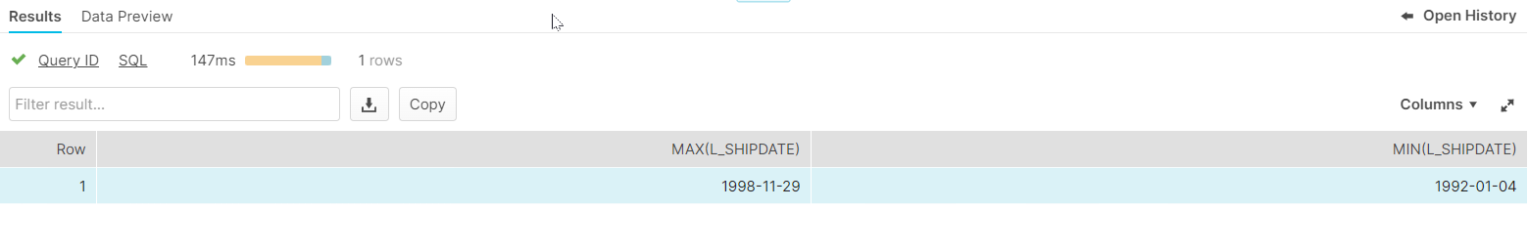

We create a view called PowerBIAnalysis which has the aggregates that we require grouped by l_returnflag and l_linestatus and ordered by l_returnflag and l_linestatus.

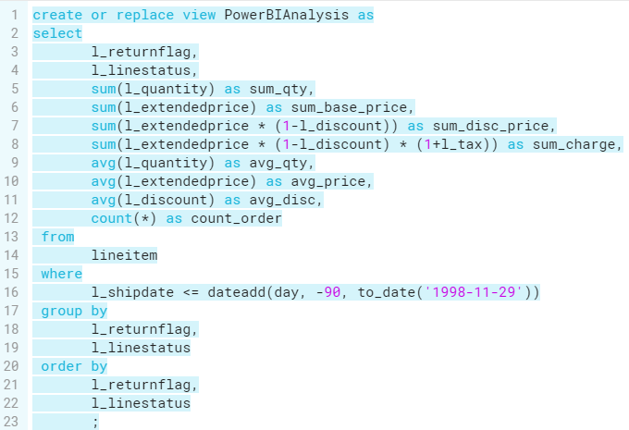

We can use the select * from PowerBIAnalysis; to get the records of the view.

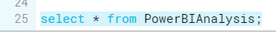

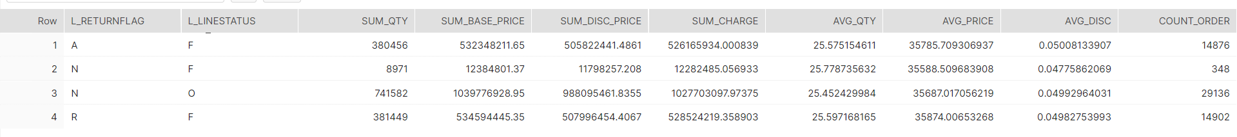

In order to visualize this view we import it to Power BI using the Snowflake ODBC connector.

**JOINS**:

1. In place Join: We create an in-place join between LINEITEM and ORDERS such that only data where L_ORDERKEY=O_ORDERKEY are returned, but we only return one row, i.e., AVG(L_QUANTITY). But the join is still performed. We can later take this aggregate and use it for Power BI visualizations.

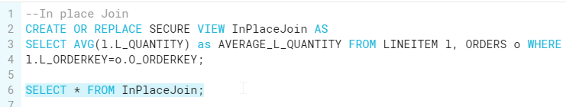

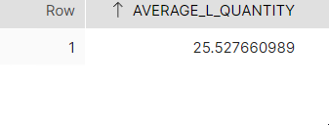

1. We find the sum of Orders.O_TOTALPRICE in each Nation using a join between Customer and Orders table considering only the sum in the year 1995 using where O.O_ORDERDATE LIKE ‘1995%’ which means the O_ORDERDATE must begin with 1995. Store this Join in a view and later visualize it in Power BI.

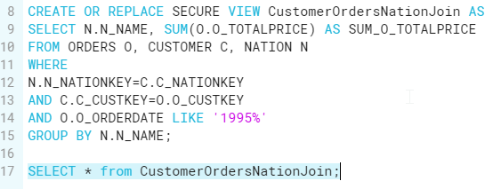

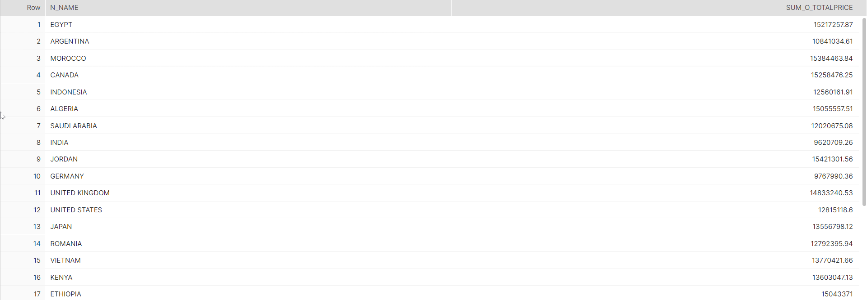

1. We have created a secure view named LARGE_QUANTITY_ORDERS.

The below query ranks customers based on them having placed a large quantity order. Large quantity orders are those orders whose total quantity is above a certain level. In our case we have kept it as 250.

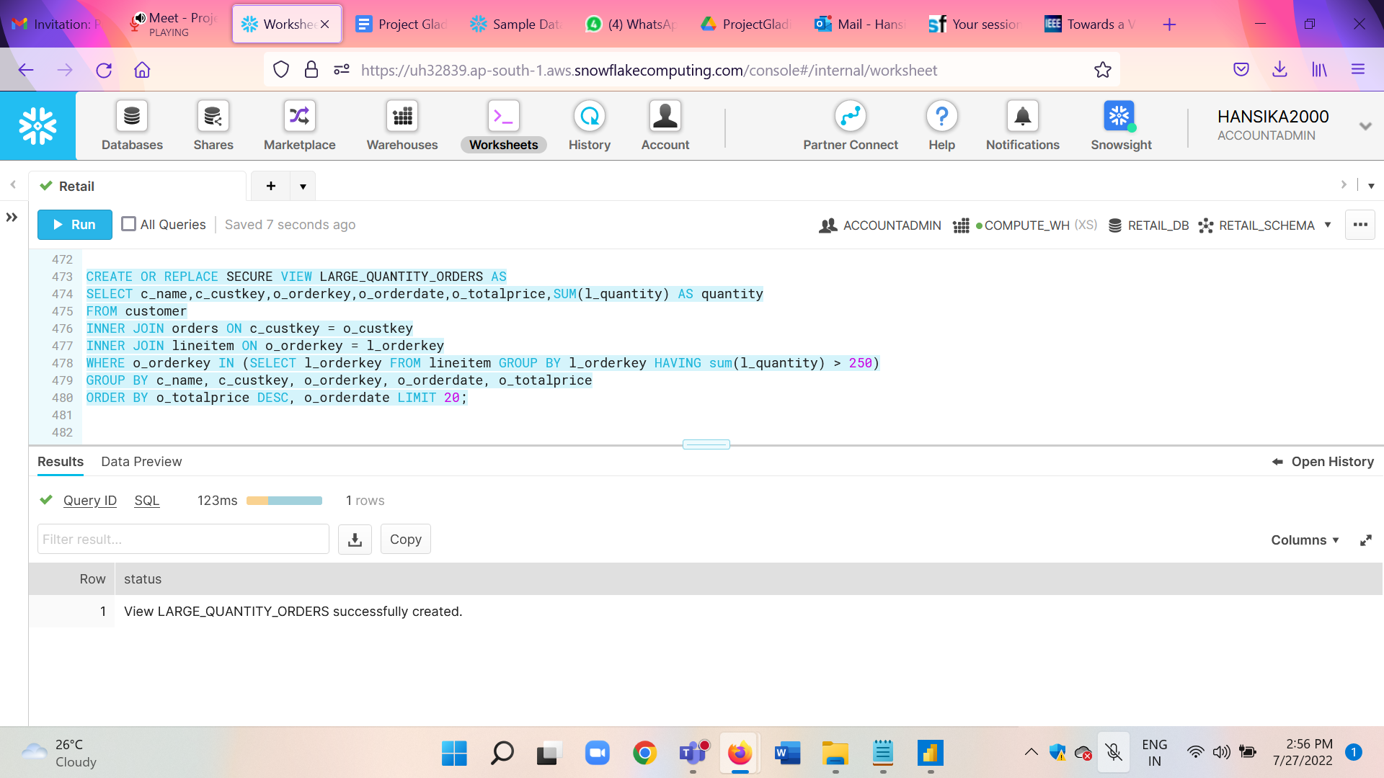

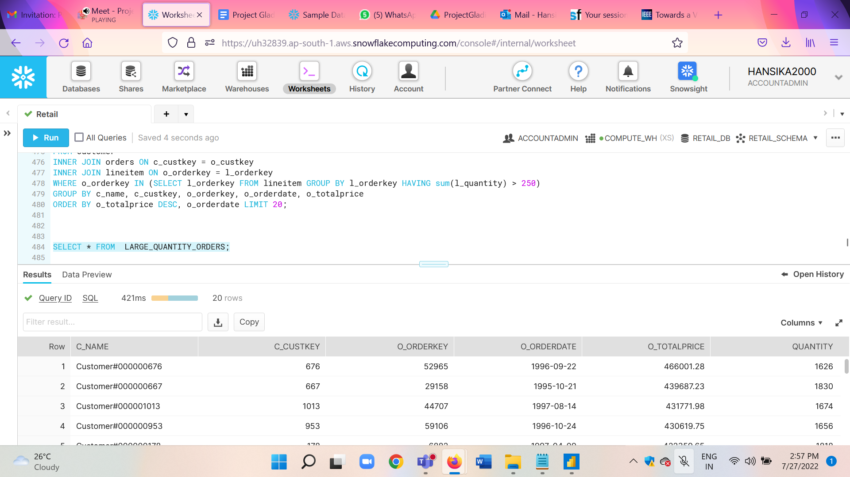

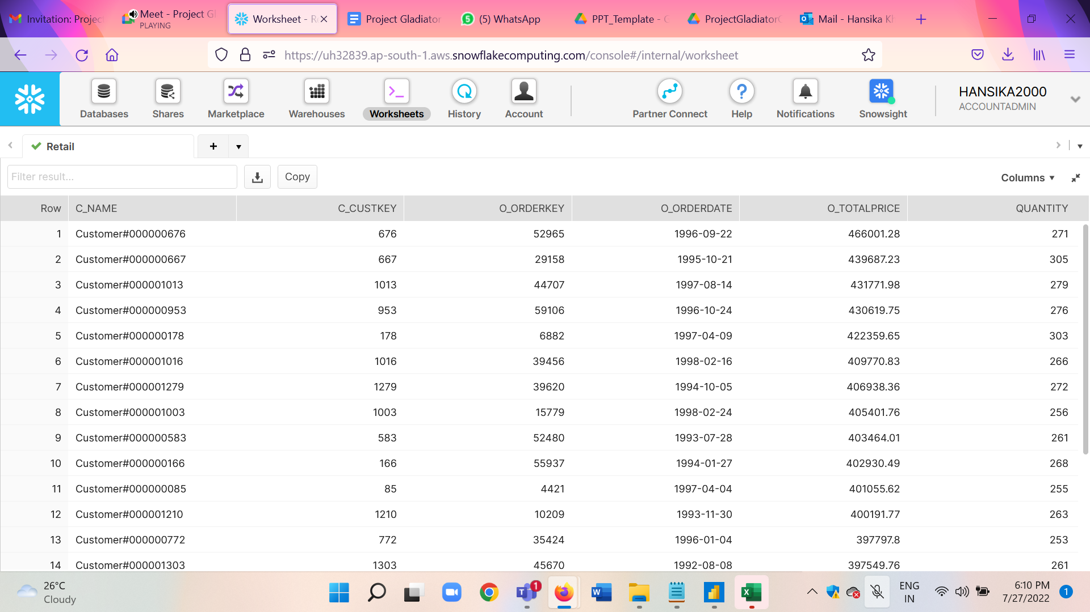

1. Here, we have created a secure view named PART_PROFIT.

The below query determines how much profit is made on a given line of parts, broken out by supplier nation and year. In our case we are computing results from the latest year in a dataset for parts that contain ‘lavender’ in their name.

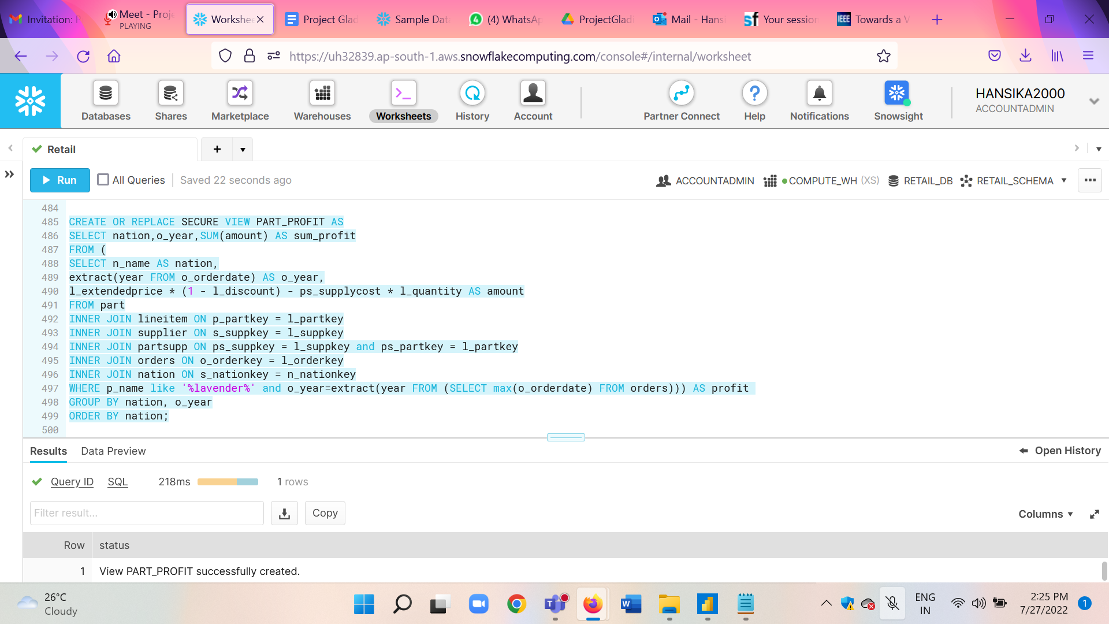

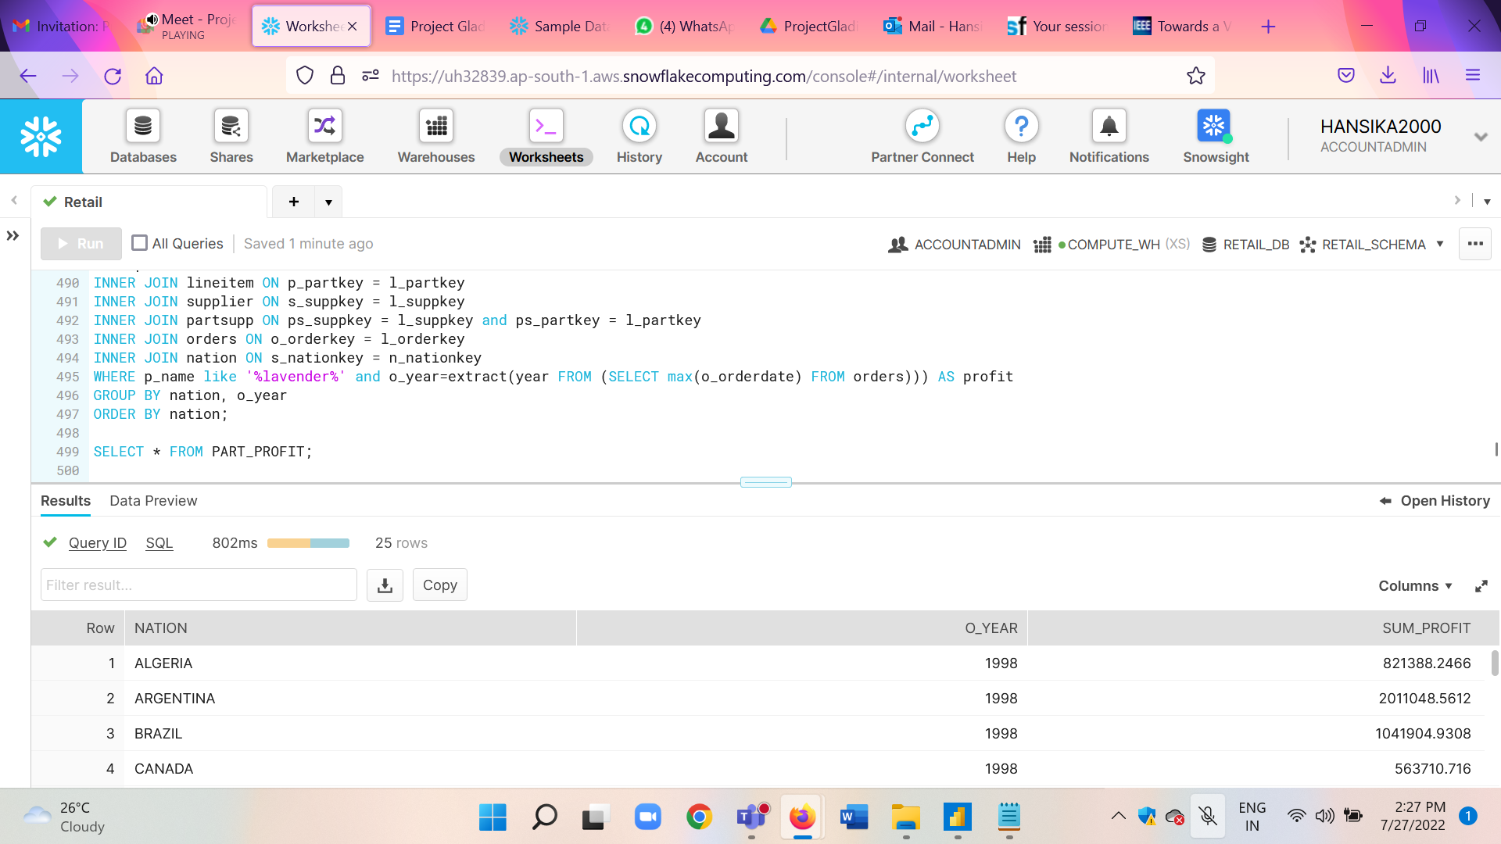

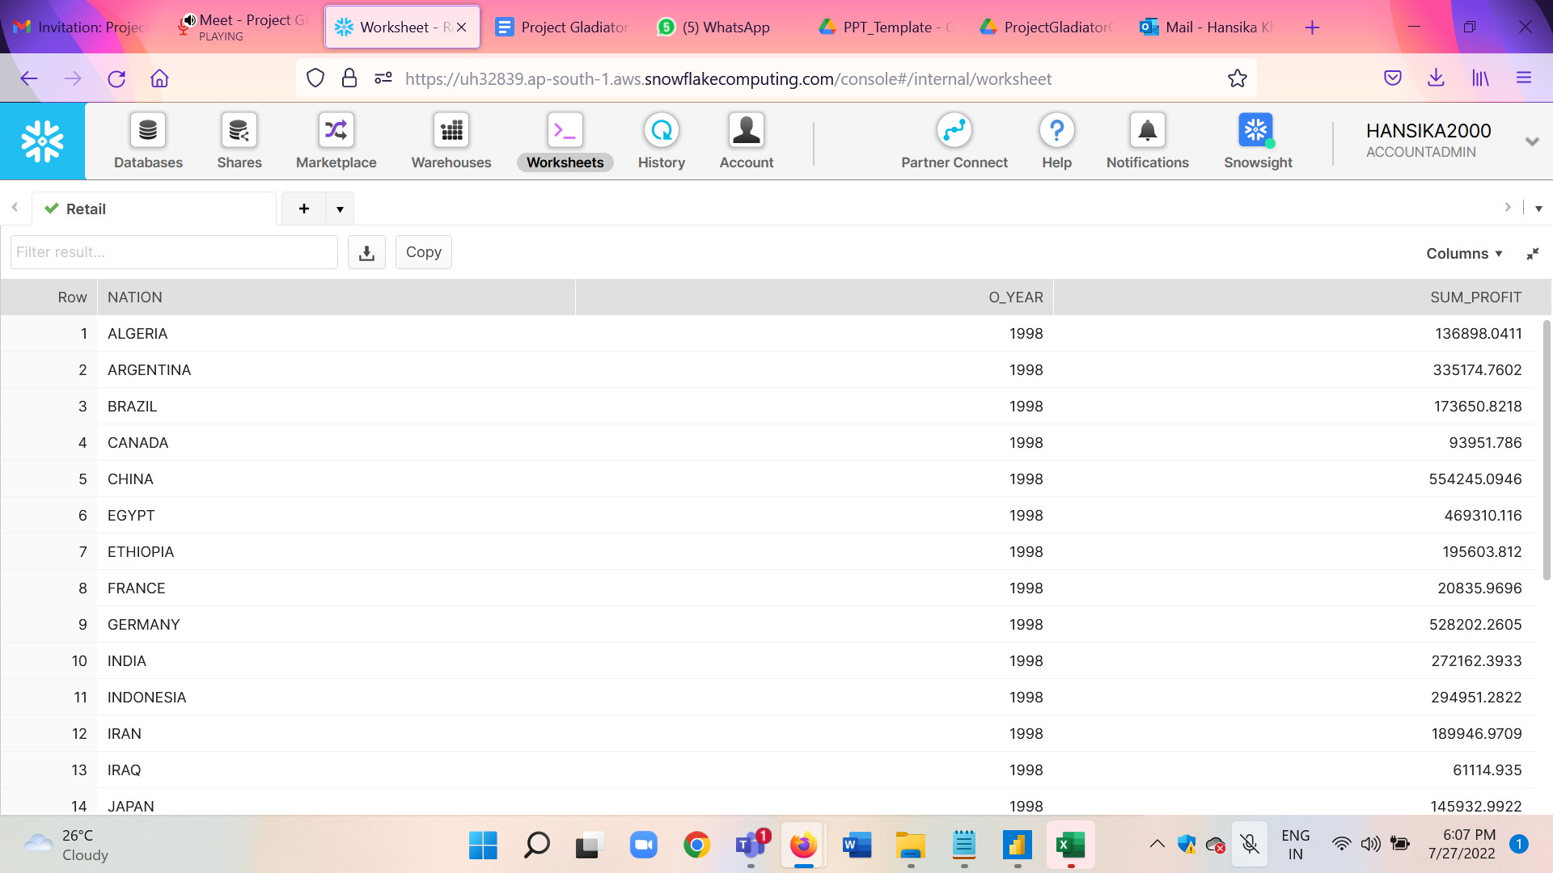

5.This query joins PART and LINEITEM on partkey which is the PK for PART and the FK for LINEITEM while performing an operation involving columns in both tables,

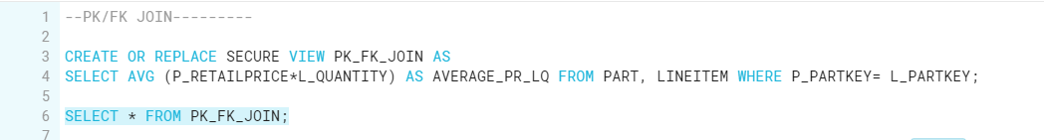

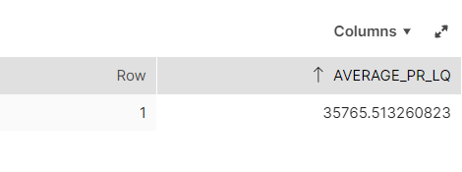

6. This query joins PART and LINEITEM on unrelated columns (p_partkey and l_suppkey) while performing a sum so that only one row is returned that is SUM_L_QUANTITY,

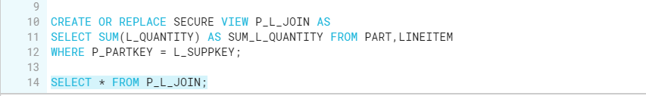

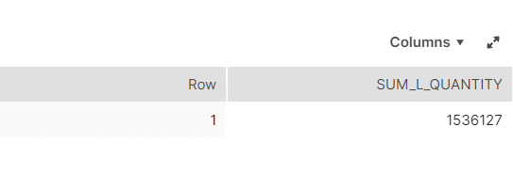

2. **Power BI Desktop Visualizations**:

1. Get Data into Power BI from snowflake.

* Select Get data from other sources.

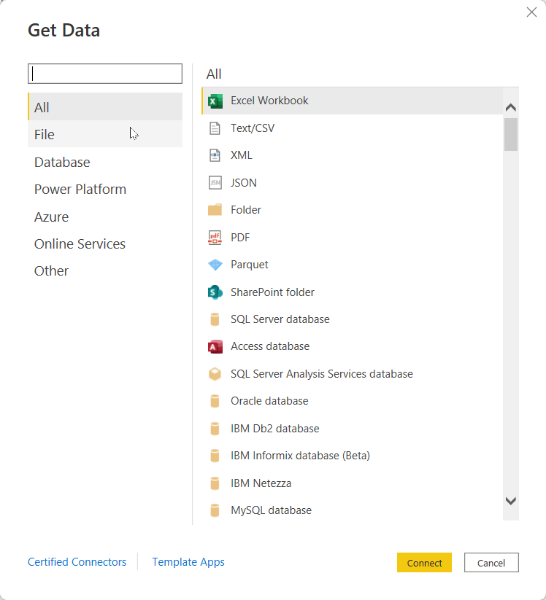

* Find Snowflake

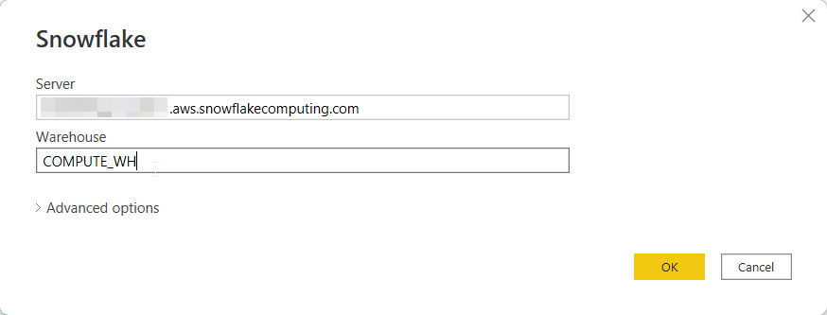

* Enter the server name and warehouse to use server: im69079.ap-south-1.aws.snowflakecomputing.com

warehouse: COMPUTE_WH

* Select all the tables and views we want.

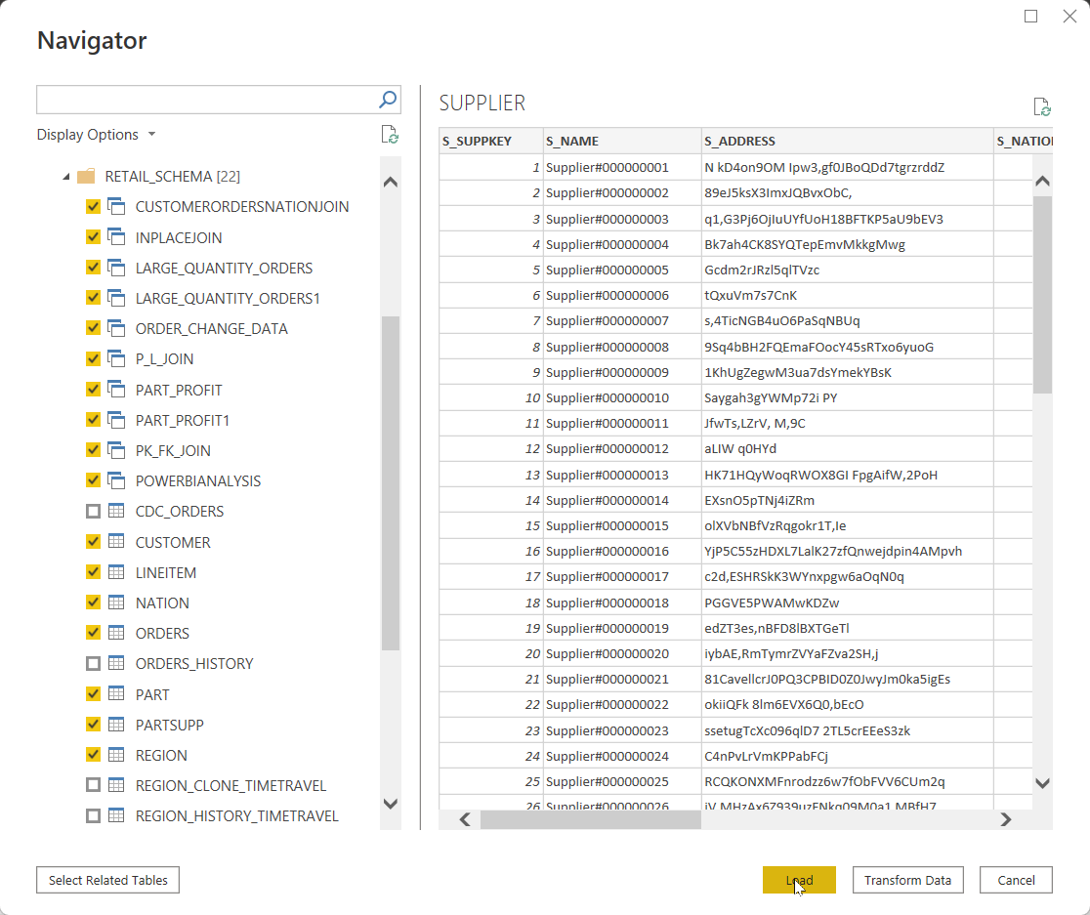

* Then click on Load, in the pop up click import, since we want to import the data from Power BI rather than DirectQuery the data from Snowflake, because the data is of fixed nature.

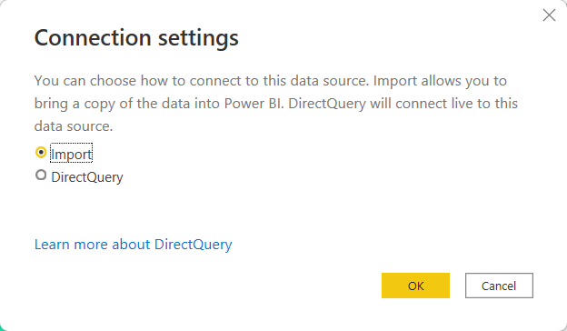

* Then the tables are loaded. Save the file as RetailCaseStudy.pbix.

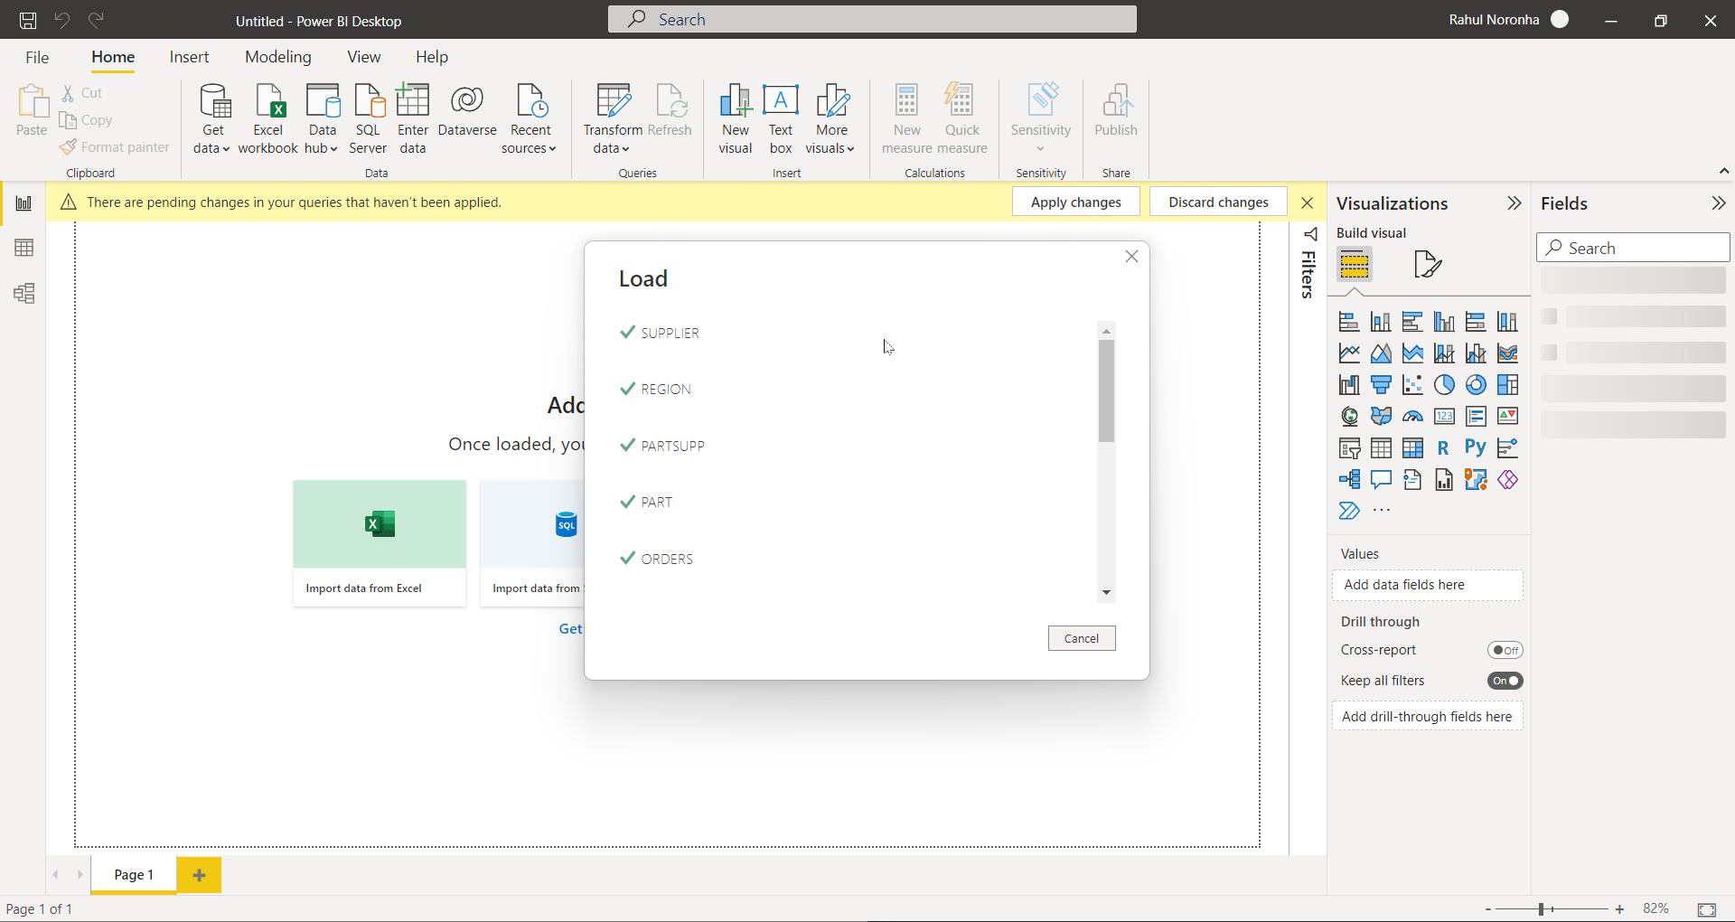

1. Use the view PowerBIAnalysis to create the following visualization
   1. Average Quantity grouped by L_RETURNFLAG and L_LINESTATUS, and ordered by L_RETURNFLAG and L_LINESTATUS

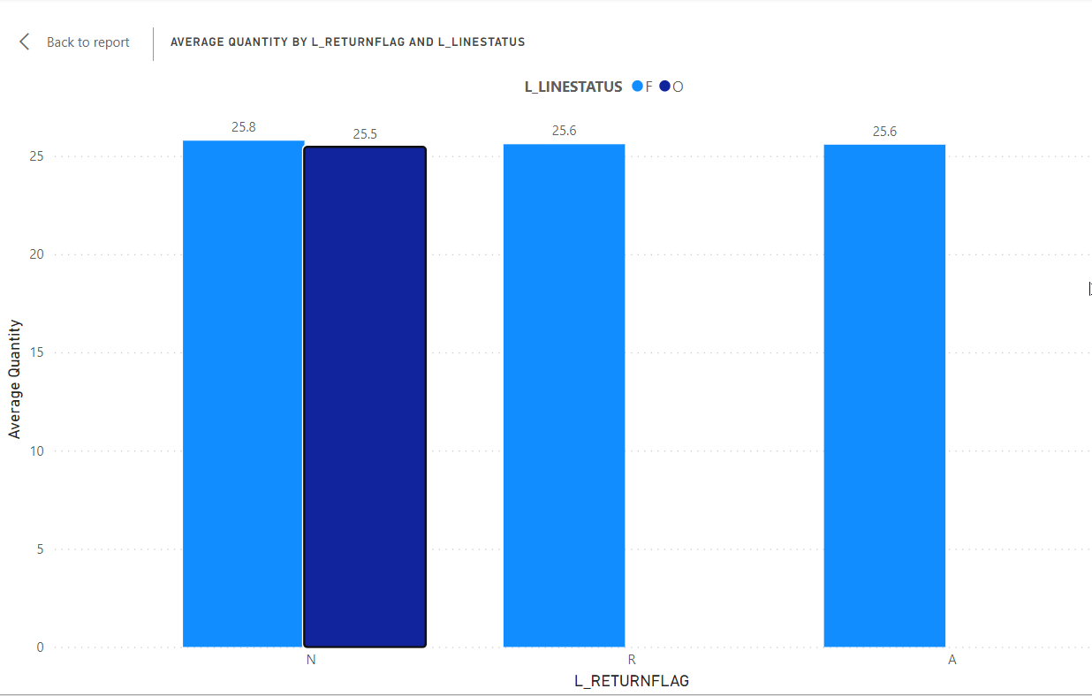

* 1. Average Discount grouped by L_RETURNFLAG and L_LINESTATUS, and ordered by L_RETURNFLAG and L_LINESTATUS

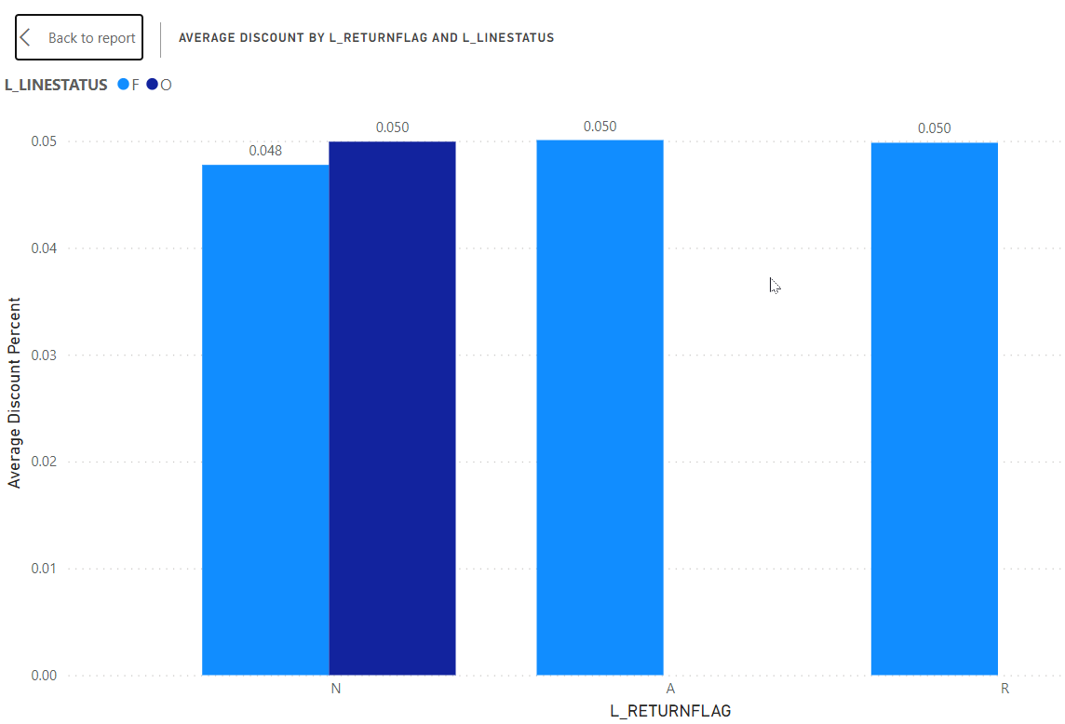

* 1. Average Price grouped by L_RETURNFLAG and L_LINESTATUS, and ordered by L_RETURNFLAG and L_LINESTATUS

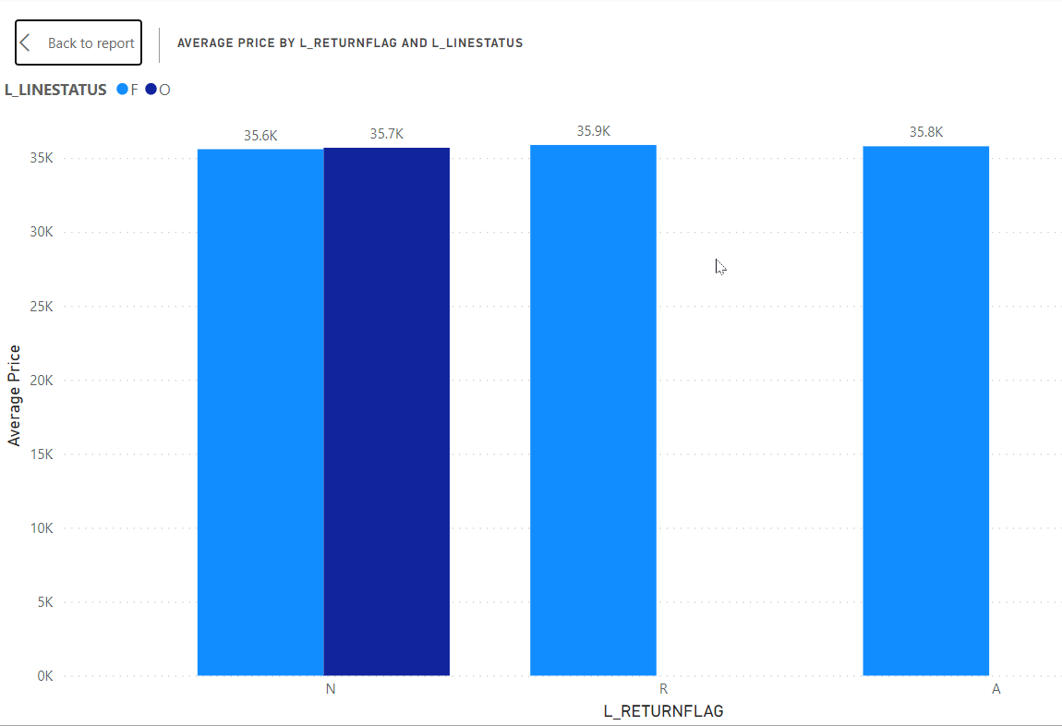

* 1. Count of Order grouped by L_RETURNFLAG and L_LINESTATUS, and ordered by L_RETURNFLAG and L_LINESTATUS

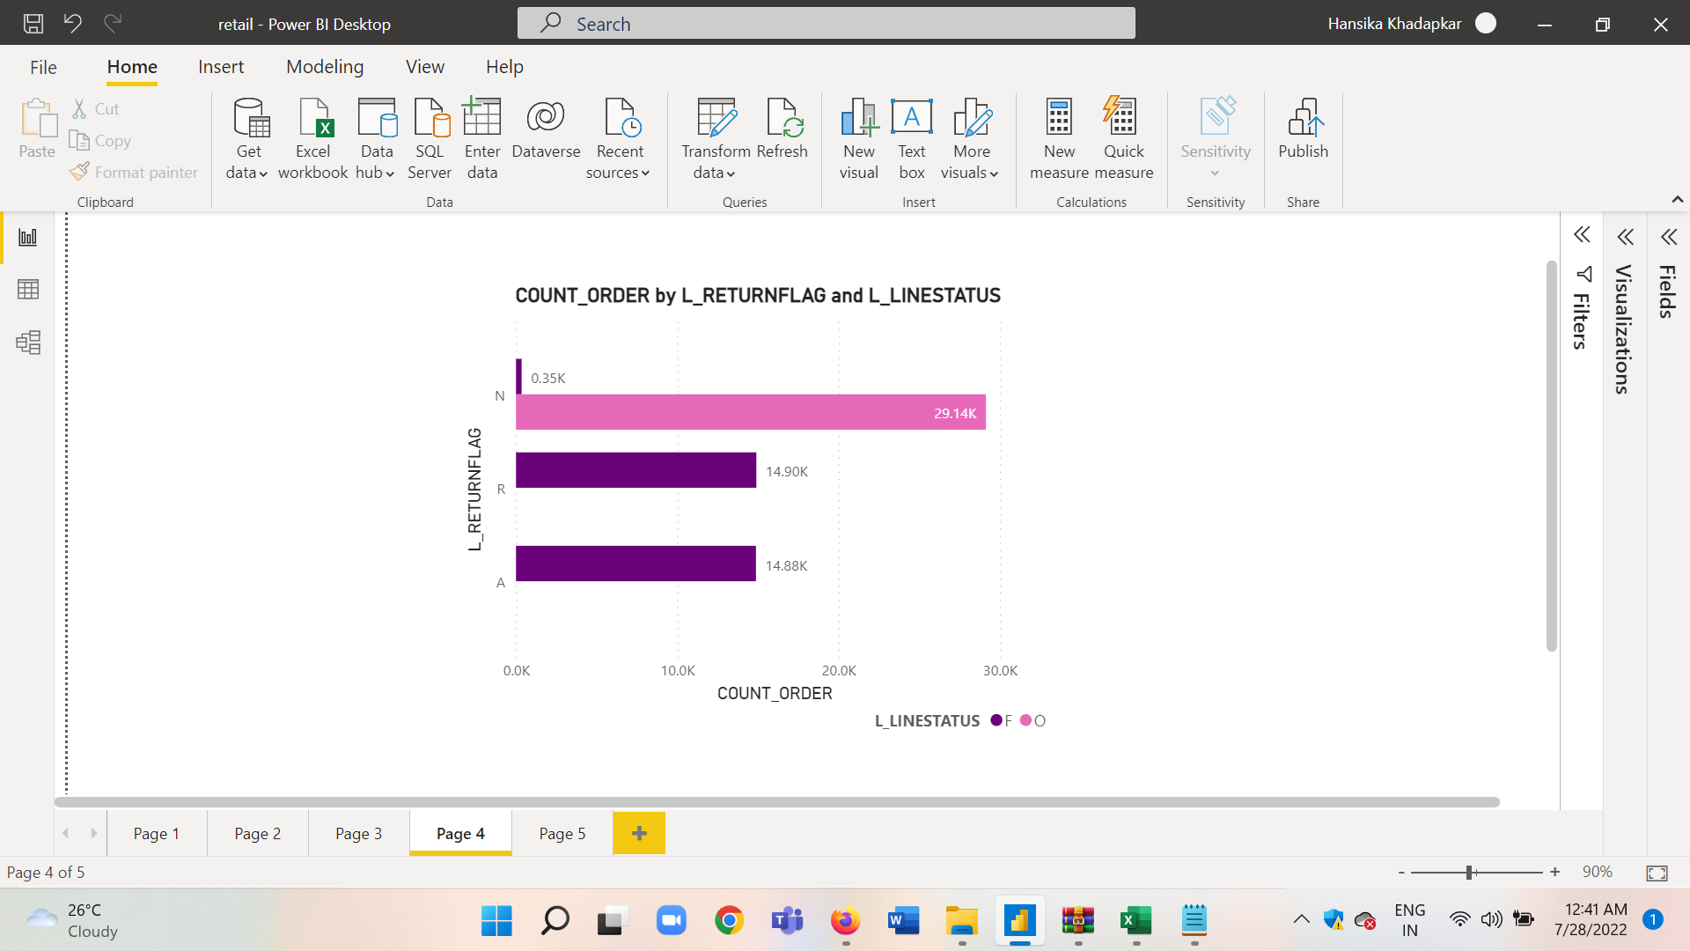

* 1. Total base price grouped by L_LINESTATUS and L_RETURNFLAG and ordered by L_LINESTATUS and L_RETURNFLAG.

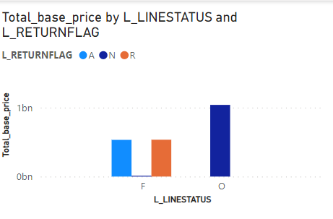

* 1. Total Quantity grouped by L_LINESTATUS and L_RETURNFLAG and ordered by L_LINESTATUS and L_RETURNFLAG.

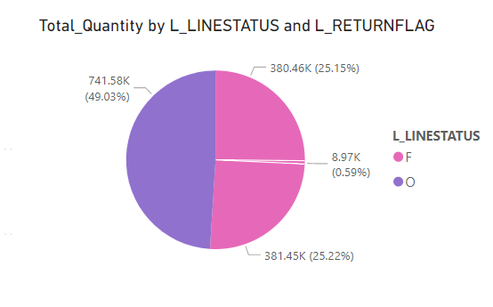

* 1. Total discount grouped by L_LINESTATUS and L_RETURNFLAG and ordered by L_LINESTATUS and L_RETURNFLAG.

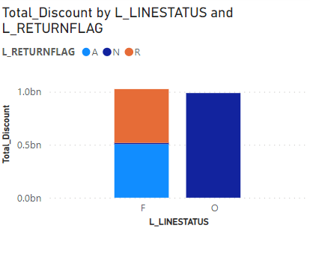

1. Use the view CustomerOrdersNationJoin to create the following visualization
2. Total Order price per Nation

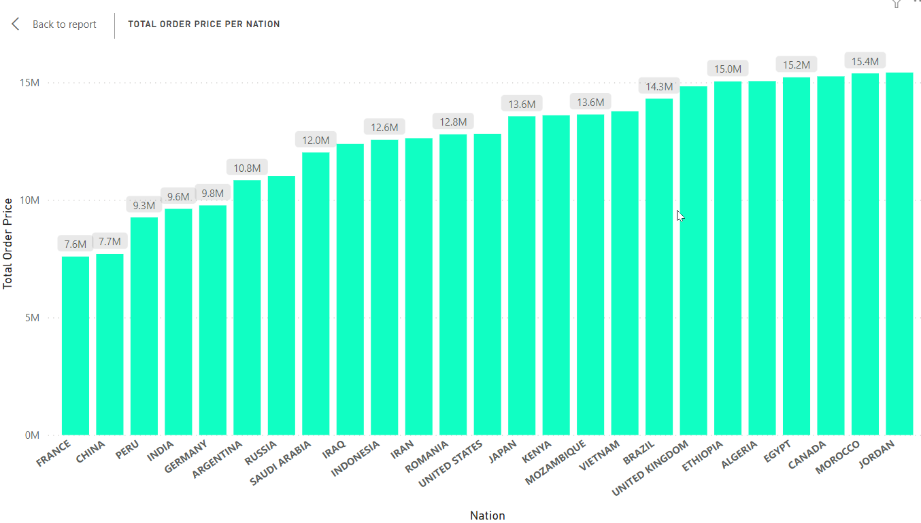

1. Use the view InPlaceJoin to create the following visualizations
2. Sum of L_QUANTITY from LineItem

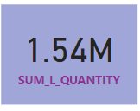

4. Use the view LARGE_QUANTITY_ORDERS to create following visualization

Top 20 customers with largest quantity orders

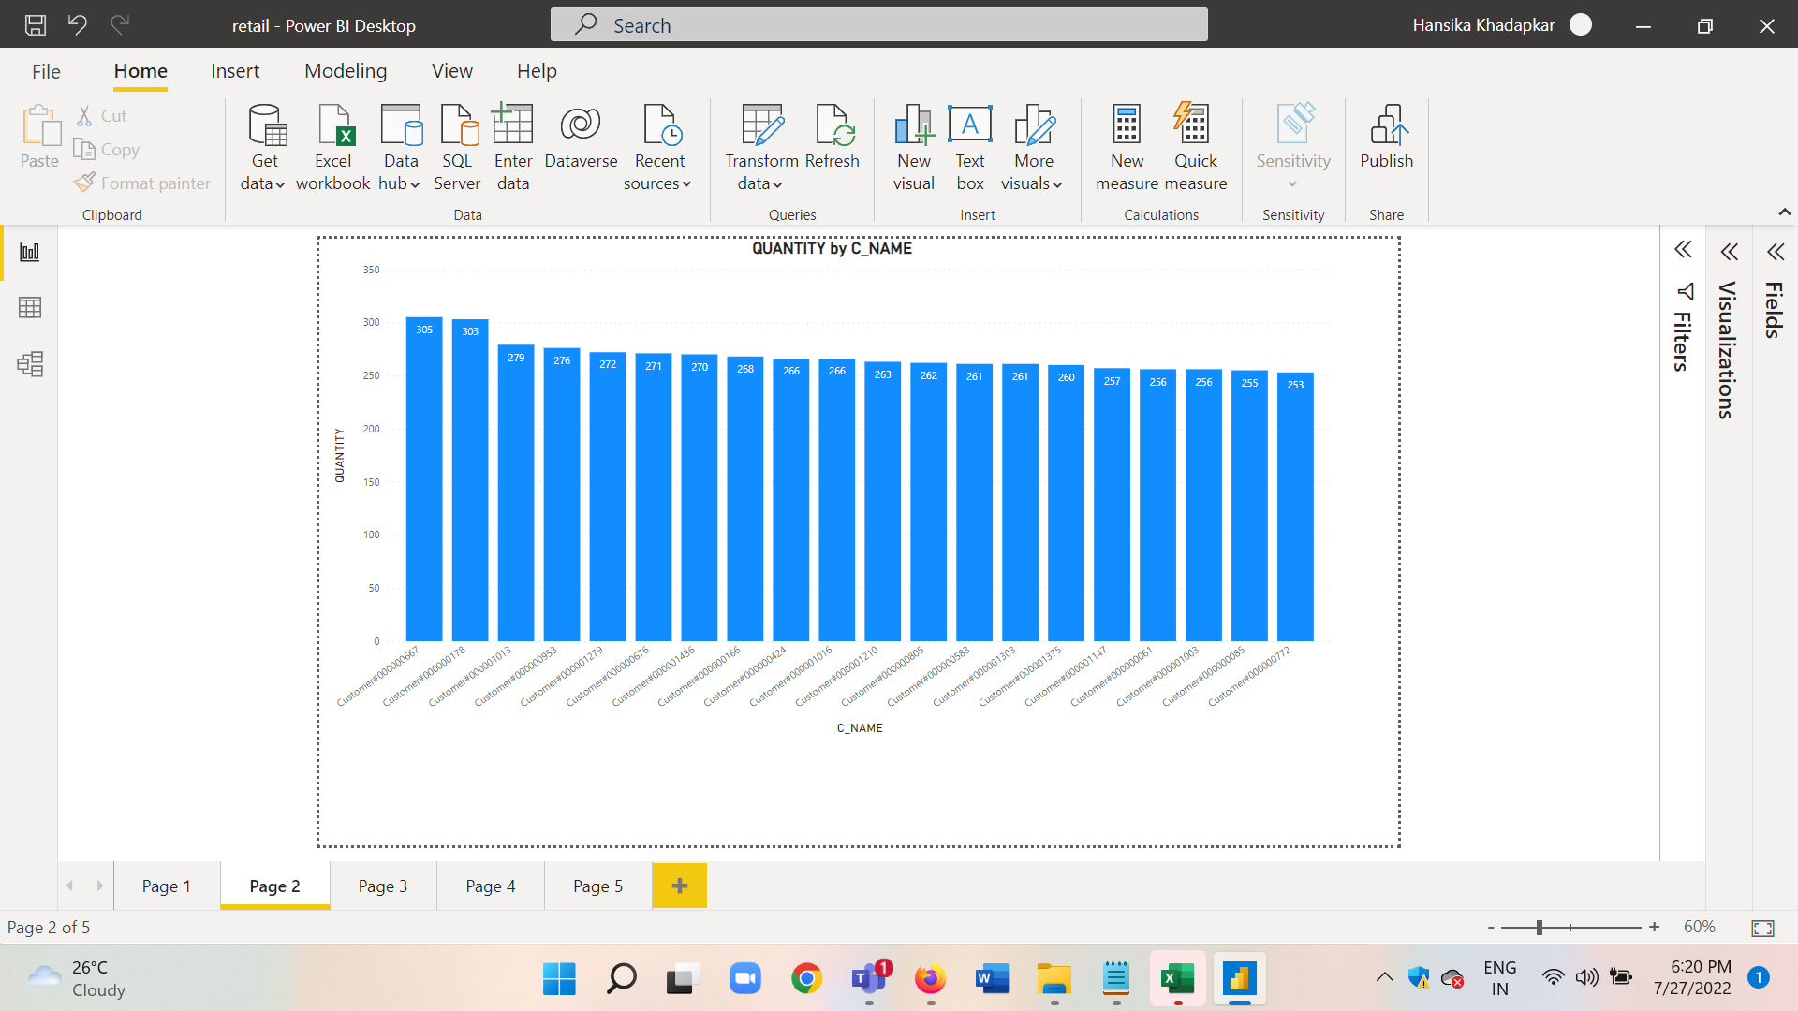

5. Use the view LARGE_QUANTITY_ORDERS to create following visualization

Nation wise profit

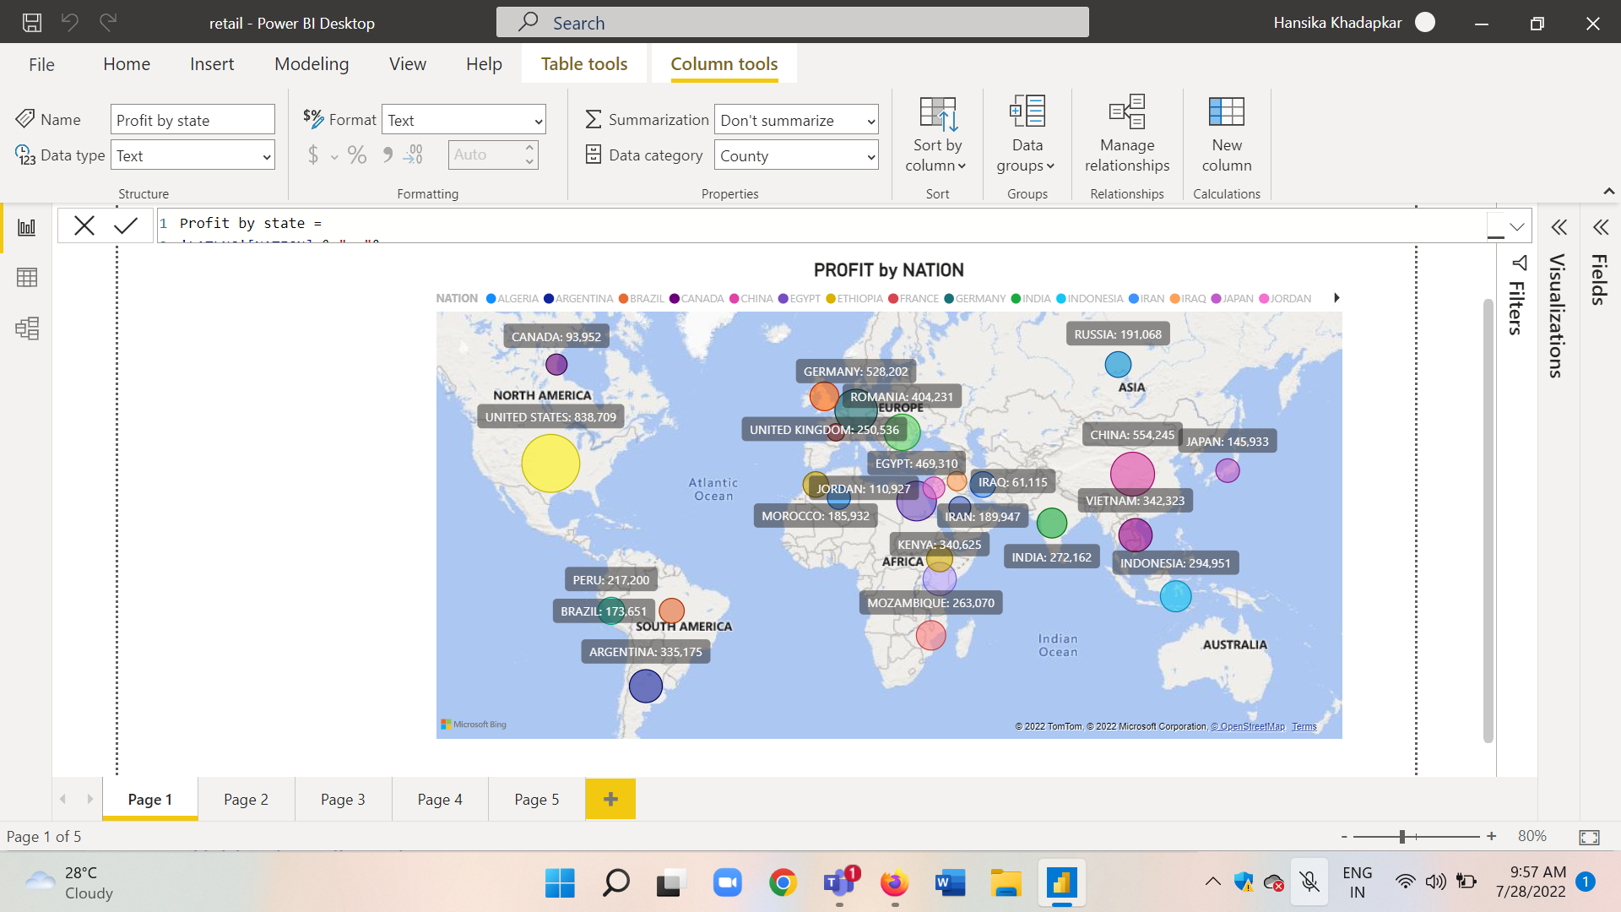

Before checking for new visualizations possible, connect the tables using the Model section via Manage relationship box or drag and drop.

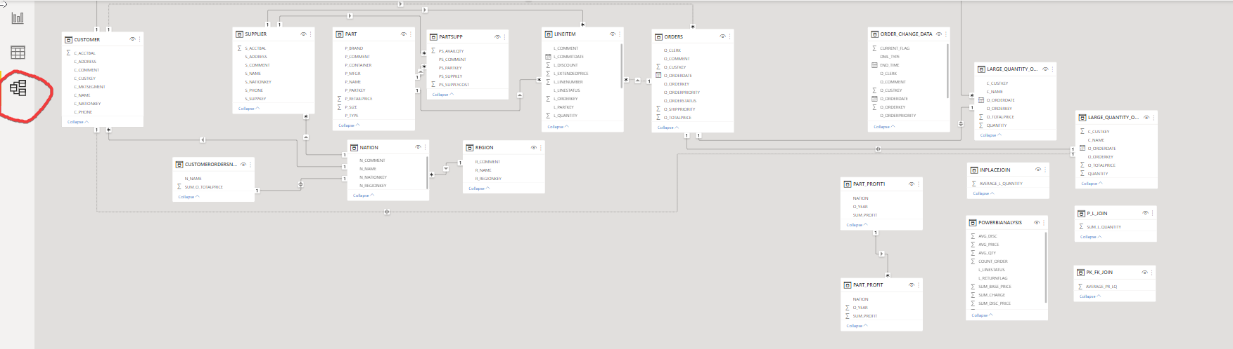

6. Few other queries we can create on the data model are as follows

* 1. Total Order price per customer

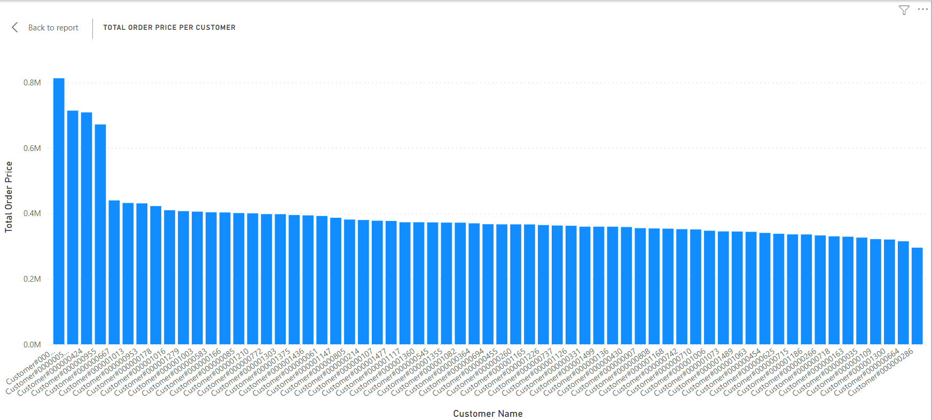

* 1. Count of customers by nation

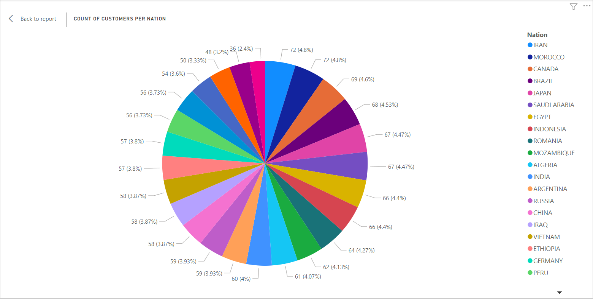

* 1. Total discount and Total charge by Nations

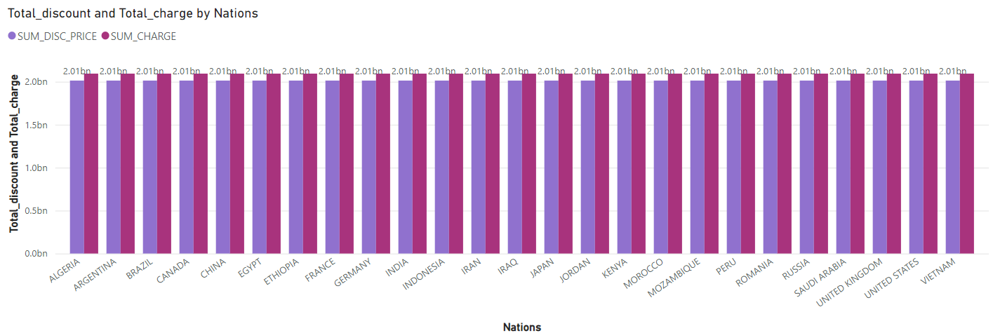

* 1. Count of customers per Nation

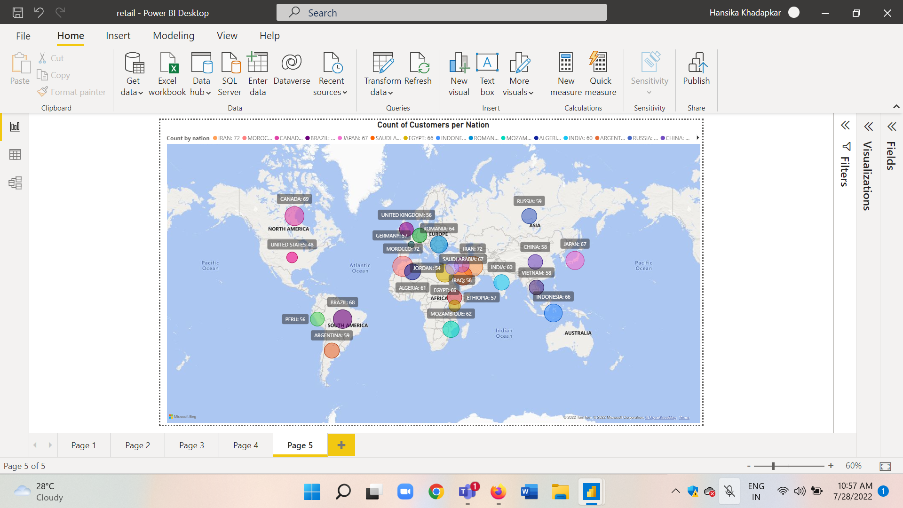

**Dashboards**:

1. **Retail Case Study Dashboard 1**
   1. **Web View**

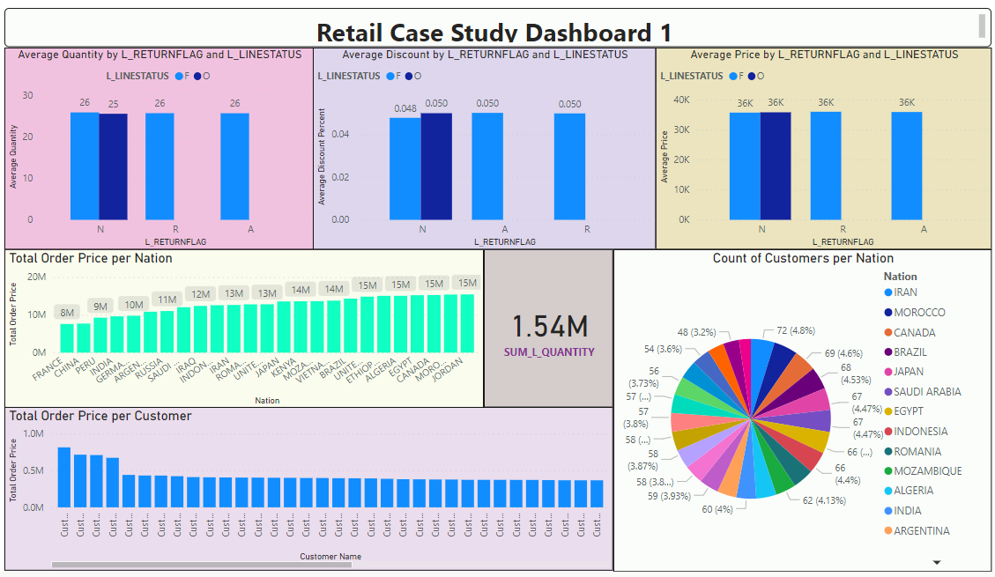

* 1. **Mobile View**

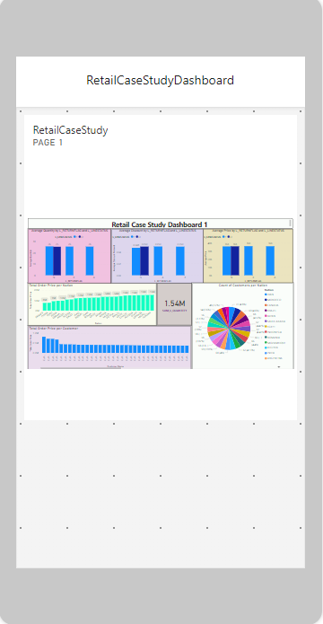

1. **Retail case study Dashboard 2**
2. **Web View**

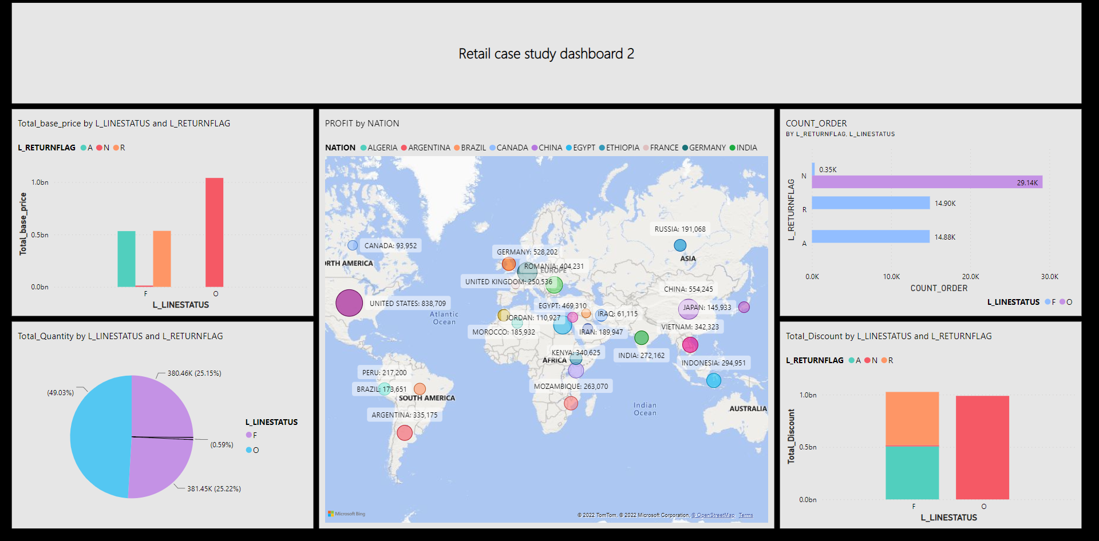

1. **Mobile view Retail case study dashboard 2**

